Table of Contents

List of Figures 4
List of Tables 5
1 Preamble 6
2 Purpose 7
3 Acronyms 8
4 Reference Documentation & Codes and Standards 9
4.1 Applicable Documents 9
4.2 Material and Coating Specification 9
4.3 Applicable Codes and Standards 10
4.4 Reference Documents 11
5 Scope of Work 12
5.1 Component Description 13
5.1.1 DNB Liner 16
5.1.2 HNB Plate 14 21
5.1.3 HNB Plate 16 23
5.1.4 HNB Plates 15 27
5.2 Supply Scope 30
5.2.1 Fabrication Scope 30
5.2.2 Integration Scope 31
5.2.3 Contract Execution 33
5.2.3.1 Task 1 Qualification_1a 33
5.2.3.2 Task 1 Qualification_1b +1c 35
5.2.3.3 Task 2 Production 36
5.3 Design requirements 37
5.4 Manufacturing requirements 38
5.5 HIP joint requirements 39
5.6 Interface requirements 39
5.7 Vacuum requirements 39
5.8 Bolting 40
5.9 Material 40
5.9.1 General Requirements 40
5.9.2 Bulk Material Specifications 41
5.9.3 Coating Specifications 41
5.9.4 Other Materials 42
5.10 Examinations 42
5.10.1 General Requirements 42
5.10.2 Calibration of measuring equipment 43
5.10.3 Qualification of personnel 43
5.10.4 Visual Examination 43
5.10.5 Examinations of Welds 44
5.10.6 Examinations of Materials 44
5.10.7 Non-destructive Examinations during manufacturing 44
5.10.7.1 Ultrasonic Examination 44
5.10.7.2 Acceptance Criteria for the CuCrZr-IG to 316L(N)-IG Joint and 316L(N)-IG to 316L(N)-IG Joint 44
5.10.7.3 Non-destructive Examinations for vacuum boundary wall less than 5 mm thick 45
5.10.8 Archival and Witness Samples 46
5.11 Acceptance Criteria 46
5.11.1 Acceptance Criteria for the Welding 46
5.11.2 Acceptance Criteria for Materials 46
5.11.2.1 Acceptance criteria for CuCrZr-IG 46
5.11.2.2 Grain Size for CuCrZr-IG 46
5.11.2.3 Acceptance Criteria for the Hardness of Stainless Steel 47
5.12 Acceptance Tests 47
5.12.1 Visual examination 50
5.12.2 Non-blocking test 50
5.12.3 Hydraulic Pressure Test 50
5.12.4 Helium Leak Test 51
5.12.4.1 Helium Leak Testing at Room Temperature 51
5.12.4.2 Helium Leak Test at Elevated Temperature 51
5.12.5 Geometrical Shape and Tolerances 59
5.12.5.1 Introduction 59
5.12.5.2 General Tolerances 59
5.12.5.3 Specific Tolerances 59
5.13 Component Labelling and Traceability 60
5.14 Cleaning 60
5.15 Packing, preservation & shipping 60
6 Location for Scope of Work Execution 61
7 IO Documents & IO Free issue items 61
7.1 IO Documents 61
7.2 Free issue items 62
7.3 IO Service 62
8 Deliverables and Schedule Milestones 63
8.1 Schedule for delivery Hardware 63
8.2 List of deliverable documentation 64
9 Quality Assurance requirements 66
10 Safety requirements 66
10.1 Nuclear class Safety 66
10.2 Seismic class 66
11 Special Management requirements 66
11.1 CAD design requirements 66
12 Appendix 66
Appendix A1 - Qualification of Hot Isostatic Pressing for CuCrZr to Steel and Steel to Steel bonds 67
A1_1 SCOPE 67
A1_1.1 Preliminary HIP Procedure Specification 67
A1_1.2 Qualification of the HIP procedure 67
A1_2 Geometry of the test piece 67
A1_3 Essential parameters 67
A1_3.1 Parent Materials 67
A1_3.2 Surface Roughness 68
A1_3.3 Cleanliness before and during operation 68
A1_3.4 Gaps and misalignments due to machining and assembly tolerances 68
A1_3.5 Welds 68
A1_3.6 Canister 68
A1_3.7 HIP furnace 68
A1_3.8 HIP cycles 69
A1_3.9 Heat treatment 69
A1_3.10 Contamination protection 69
A1_4 Tests 69
A1_4.1 Destructive test 69
A1_4.1.1 Transverse Tensile test 69
A1_4.1.2 Bend test 70
A1_4.1.3 Metallographic examination 70
A1_4.1.4 Oxidation 70
A1_4.2 NDT 71
A1_4.2.1 Penetrant test 71
A1_4.2.2 UT 71
A1_4.2.3 Micro hardness test 71
A1_4.2.4 Leak and burst test 72
A1_5 HIP Process Qualification Record 72
- End of the Document - 72

List of Figures
Figure 5-1. Neutral Beam Port Liners 13
Figure 5-2. The NBPL, located at the Neutral Beam Ports, consist of one DNB liner (in blue) and twelve HNB plates (four plates in each of the three HNB ports 14
Figure 5-3. List of NBPL components and Integrated Shield Blocks 15
Figure 5-4. Diagnostic Neutral Beam liner (for information only) 17
Figure 5-5. DNB Liner and its Standard Parts (for information only) 18
Figure 5-6. Detail of DNB PAD Assembly that interact with the VV shear keys (for information only) 18
Figure 5-7. Detail of DNB M14 Bolt Assembly that interact with the VV rails (for information only) 19
Figure 5-8. Customization capability for DNB M14 Bolt Assembly that interact with the VV rails (for information only) 19
Figure 5-9. DNB slot (Keyway) to be machined according to as-built data from VV Sector#02 (for information only). Coating (or layer) may be applied on the DNB slot to be determined after IO assembly trials. 20
Figure 5-10. Heating Neutral Beam Plate 14 (for information only) 21
Figure 5-11. The integrated Shield Block 14 (The HNB Plate 14 attached to the bottom of SB14) (Manufacturing of SB14 is out of scope as they are Free Issued Item from CNDA) 21
Figure 5-12. Cross section of the HNB Plate 14 to SB14 (for information only) 22
Figure 5-13. Perpendicular cross-section from Figure 5-12 at one hydraulic interface (Cap) and at one bolt interface (Bolt, Nord Lock washer, insert and pin). 22
Figure 5-14. Bolt for HNP Plate 14 applied with ASC coating 22
Figure 5-15. Heating Neutral Beam Plate 16 and its exploded view (for information only). 23
Figure 5-16. The HNB Plate 16 plasma facing area is optimized for heat transfer for the beam and plasma loads with aggressive cooling and chamfers to shadow the highest loads. 24
Figure 5-17. HNB Plate 16 Cooling Overview (Deep drilling holes). 24
Figure 5-18. The Integrated Shield Block 16 (HNB Plate 16 attaches to the top of SB16) 25
Figure 5-19. The bolts pass through the back side of SB16 into the HNB Plate 16 (the axis deviation of 5 degrees between the hydraulic connection and the bolts; the standard parts of the Integrated SB16 including bolts, Nord Lock washer, insert, pin and Caps). 26
Figure 5-20. Cross section of the HNB Plate 16 to SB16 (the axis deviation of 5 degrees between the hydraulic connection and the bolts; the standard parts of the Integrated SB16 including bolts, Nord Lock washer, insert, pin and Caps) 26
Figure 5-21. Heating Neutral Beam Plates 15 (SS/CuCrZr/SS HIP bonded, some cutout machined after HIP onto SB15NDx, for information only) 27
Figure 5-22. HNB Plates 15 Cooling Volume Overview (Deep drilling holes, some cutout machined after HIP onto SB15NDx, for information only) 27
Figure 5-23. The Integrated Shield Block 15NDA (some cutout machined after HNB Plate 15 HIPed onto SB15NDx, for information only) 28
Figure 5-24. Cross-section of Integrated Shield Block 15 (some cutout machined after HNB Plates 15 HIPed to the SB15NDx, Cap Long is out of scope, which to be welded with the Integrated SB15NDx at ITER site) 28
Figure 5-25. Interface on the Integrated SB15NDA (for information only) 29
Figure 5-26. Interface with PBS 55TIP on the Integrated SB15NDA (Interface with TIP including self-lock insert and pin) 29
Figure 5-27. Quantity of NBPL components for fabrication (spares are to the right of the dotted line). 30
Figure 5-28. Integration with HNB Plates 15 and SB15NDx via HIP (for information only) 31
Figure 5-29. Integration of HNB Plates 14&16 to corresponding SB via welding and bolting interface (for information only) 32
Figure 5-30 Schematic illustration of Hot Helium leak test sequence and related acceptance criteria 58
Figure 5-31 Schematic illustration of a hot Helium leak test facility (example) 58

List of Tables
Table 5-1 Classification of NBPL components 15
Table 5-2 Minimum Mechanical Properties After Manufacturing. 46
Table 5-3 Summary of Acceptance Test 49
Table 5-4 Hydraulic Pressure Test requirements and acceptance criteria 50
Table 5-5 The outline procedure and acceptance criteria for helium leak test at elevated temperature 52

Preamble
This Technical Specification is to be read in combination with the General Management Specification for Service and Supply (GM3S) [AD1] that constitutes a full part of the technical requirements.
In case of conflict, the content of this Technical Specification supersedes the content of the GM3S [AD1].

Purpose
This document describes the technical requirements for the procurement of Neutral Beam Port Liners (NBPL) and the integration of Heating Neutral Beam Plates to their corresponding Shield Blocks. The NBPL components are a part of the Blanket System which provide additional nuclear and thermal shielding to the Vacuum Vessel and Blanket Modules around the Heating and Diagnostic Neutral Beam ports.
This technical specification provides all technical requirements related to the scope of supply, code and standards, manufacturing requirements, and acceptance requirements. It applies to the following systems:
- the Diagnostic Neutral Beam (DNB) Liner
- the Heating Neutral Beam (HNB) Plates
- the integration of HNB Plates to their corresponding Shield Blocks

Each technical requirement in this technical specification is formally identified.
A requirement unambiguously starts with a paragraph containing the string [REQ-N], where N is the requirement number. Each requirement related to the Appendix A1 starts with a paragraph containing the string [A1_REQ-N].

Acronyms
The following acronyms are the main one relevant to this specification, see the complete list in the ITER Abbreviations [RD1].

Abbreviation | Description
ASTM | American Society for Testing and Materials
COTS | Commercial Off-the-Shelf
DNB | Diagnostic Neutral Beam
DIP | Dimensional Inspection Plan
EN | European Standard
ESR | Electro-Slag Remelted
FAT | Factory Acceptance Test
FII | Free-Issued Items
GM3S | General Management Specification for Service and Supply
HIP | Hot Isostatic Pressing
HNB | Heating Neutral Beam
HP | Hold Point
HPQR | HIP Process Qualification Record
HV | Vickers Hardness
Integrated SB14 | The integration of HNB Plates 14 to Shield Block 14NDx (ND, NDL, and NDV) via welding and bolting interface
Integrated SB15 | The integration of HNB Plates 15 to Shield Block 15NDx (ND, NDA, NDB and NDS) via HIP
Integrated SB16 | The integration of HNB Plates 16 to Shield Block 16NBx (NB and NB1) via welding and bolting interface
IO | ITER Organization
ISO | International Standard Organization
MRR | Manufacturing Readiness Review
NB | Neutral Beam
NBPL | Neutral Beam Port Liner
NDT | Non Destructive Testing
RT | Room Temperature
SB | Shield Block
SDC-IC | Structural Design Criteria for ITER In-vessel Components
UT | Ultrasonic Testing
VAR | Vacuum Arc Remelted
VQC | Vacuum Quality Classification
VT | Visual Testing
VV | Vacuum Vessel

Reference Documentation & Codes and Standards
The reference documentation includes Applicable Documents (to which the procurement must comply) and Reference Documents (which provide background information).

Applicable Documents
This is the responsibility of the Contractor to identify and request for any documents that would not have been transmitted by IO, including the below list of Applicable Documents. The Applicable Documents will be made available to the Contractor as part of the technical specifications.
This Technical Specification takes precedence over the Applicable Documents. In case of conflicting information, this is the responsibility of the Contractor to seek clarification from IO.
[REQ-1] Upon notification of any revision of the Applicable Documents transmitted officially to the Contractor, the Contractor shall advise within 4 weeks of any impact on the execution of the contract. Without any response after this period, no impact will be considered.

Ref | Title | IDM Doc ID | Version
[AD1] | General Management Specification for Service and Supply (GM3S) | ITER_D_82MXQK | v1.4
[AD2] | ITER Vacuum Handbook | ITER_D_ 2EZ9UM | v2.5
[AD3] | ITER Dimensional Metrology Handbook | ITER_D_46FN9B | v2.1
[AD4] | Bill of Materials for the NB Port Liners (16.NL) | ITER_D_XFUSPJ | v3.1
[AD5] | NBPL Bolt Specification (Bolt List) | ITER_D_WVGVBS | v5.0
[AD6] | Generic Appendix B1 (welding requirement) ⁽¹⁾ | ITER_D_RV2495 | v3.0
[AD7] | 1.6.P1B.CN.01 Annex B ⁽²⁾ | ITER_D_GE7YXD | v1.1
[AD8] | 1.6.P1B.KO.01 Annex B ⁽²⁾ | ITER_D_HD7UT9 | v1.1
Note:
- No Deviation Request is required in case of using welding requirement specified in Appendix B1 of 1.6.P1B.CN.01 Annex B [AD7], 1.6.P1B.KO.01 Annex B [AD8], or 1.6.P1A.CN.01 Blanket First Wall Annex B [RD9], which covered by Generic Appendix B1 (welding requirement) [AD6].
- The approved PA Change Notice and IO Deviation Request are included for both 1.6.P1B.CN.01 Annex B [AD7] and 1.6.P1B.KO.01 Annex B [AD8].

Material and Coating Specification
This is the responsibility of the Contractor to procure the relevant material and apply the coatings in according with specification.

Ref | Title | IDM Doc ID | Version
[AD9] | CuCrZr Alloy for Blanket Heat Sink Application | ITER_D_GDSW7G | v1.2
[AD10] | 316L(N)-IG ESR or VAR Forging for Blanket | ITER_D_G2VF8B | v1.2
[AD11] | 316L(N)-IG ESR or VAR Plates for Blanket | ITER_D_FUUVRQ | v1.1
[AD12] | 316L(N)-IG plate for Blanket | ITER_D_33XXJM | v1.2
[AD13] | Steel_14404_grade_316L_Plates_less 5 mm | ITER_D_U8M5ZZ | v2.0
[AD14] | Steel 316L Grade A4-80 for FPPC | ITER_D_3FR65U | v1.2
[AD15] | Steel number 1.4404 (type 316L) bars for the blanket system | ITER_D_PS2MFG | v1.2
[AD16] | Steel number 1.4980 (grade 660) bars for the BMCs | ITER_D_PS3ASG | v1.0
[AD17] | Alloy 718 for Blanket | ITER_D_G7N74Y | v1.2
[AD18] | Aluminium bronze for Blanket | ITER_D_FFSEB5 | v1.1
[AD19] | Copper Anti-seize coating specification for In-vessel components | ITER_D_TLLFHC | v4.0
[AD20] | Insulating coatings for the blanket system components | ITER_D_D25QF6 | v3.1

Applicable Codes and Standards
There are numbers of codes and standards are referred in the Applicable Documents given in Section 4.1 and 4.2, which the procurement shall comply to the relevant requirements.
This is the responsibility of the Contractor to procure the relevant Codes and Standards applicable to that scope of work.

Ref | Title
[CS1] | In-vessel Components, SDC-IC, ITER_D_222RHC v3.0
[CS2] | EN 13445-5:2014 Unfired pressure vessels - Part 5: Inspection and testing.
[CS3] | NF EN ISO 20485 Non-destructive testing - Leak testing - Tracer gas method
[CS4] | ISO 2768-1 General tolerances - Part 1: Tolerances for linear and angular dimensions not affected by individual tolerances
[CS5] | ISO 22081:2021 (Replacing ISO 2768-2) Geometric Product Specification (GPS) - Geometric Tolerancing - General Geometric Specifications and General Size Specifications
[CS6] | RCC-MR 2007, Vol. 4 “Welding”
[CS7] | EN ISO 9712:2012 or 2021 Non-destructive testing – Qualification and certification of NDT personnel – General principles.
[CS8] | EN ISO 16810 Non-destructive testing - Ultrasonic examination - Part 1: General principles.
[CS9] | EN ISO 6892-1 Metallic materials - Tensile testing - Part 1: Room temperature test method
[CS10] | EN ISO 6892-2 Metallic materials - Tensile testing - Part 2: Method of test at elevated temperature
[CS11] | ISO 3696 Water for laboratory analytical use - Specification and test methods
[CS12] | EN ISO 4136 Destructive tests on welds in metallic materials - Transverse tensile test
[CS13] | EN ISO 5173 Destructive testing of welds on metallic materials - Bending tests
[CS14] | ISO 17639 Destructive testing of welds on metallic materials - Macroscopic and microscopic examinations of welded assemblies
[CS15] | ISO 5817 Welding - Fusion welded steel, nickel, titanium and their alloys assemblies (excluding beam welding) - Quality levels in relation to defects
[CS16] | DIN 25410:2012 Nuclear facilities - Surface cleanliness of components.
[CS17] | EN ISO 3452-1 Non-destructive testing - Penetrant testing - Part 1: General principles
[CS18] | ISO 23277 Non-destructive testing of welded assemblies - Penetrant testing - Acceptance levels
[CS19] | EN ISO 9015-2 Destructive tests on welds in metallic materials - Hardness testing - Part 2: Microhardness testing of welded joints
[CS20] | ISO/IEC 17025 General requirements for the competence of testing and calibration laboratories

Reference Documents
Reference Documents shall be used as a set of guidelines to assist in executing the contract. The approved current versions are always applicable.

Ref | Title | Doc Ref.
[RD1] | ITER Abbreviations | ITER_D_2MU6W5
[RD2] | Blanket numbering system | ITER_D_UDWNAY
[RD3] | Sub-System Requirement Document (s-SRD) 16-NL (Neutral Beam Port Liners) from DOORS | ITER_D_WPQ388
[RD4] | NB Port Liners Design Description Document | ITER_D_T3HGVA
[RD5] | NB Port Liners Load Specification | ITER_D_T3HALF
[RD6] | Vacuum Leak Test Procedure Template for IDM | ITER_D_8PVNNL
[RD7] | Vacuum Leak Test Report Template for IDM | ITER_D_8PVPPU
[RD8] | Memo on Hot Helium Leak Test | ITER_D_AQJF2E
[RD9] | 1.6.P1A.CN.01 Blanket First Wall Annex B | ITER_D_GEA8UD
[RD10] | List of Deliverables Form | ITER_D_73MVYS
[RD11] | List of Deliverables Working Instruction | ITER_D_7AHAL5
[RD12] | PCR-808 - Custom Machining on a need basis of the small cut-outs at the back of the Blanket Shield Blocks | VZM96K
[RD13] | ITER Vacuum Handbook Appendices | 2FHLMC
[RD14] | Material Approval Request Database | N3SVRJ
[RD15] | Quality Requirements for IO Performers | ITER_D_22MFG4
[RD16] | Technical specification for outgassing sample | ITER_D_QUCYDA

Scope of Work
This section defines the specific scope of work, in addition to the contract execution requirement as defined in the GM3S [AD1].
[REQ-2] The NBPL items listed in Section 5.2.1 Fabrication Scope and Section 5.2.2 Integration Scope, detailed in NBPL BOM [AD4], shall be supplied to the IO.
The Contract provisions shall also include the following items:
- [REQ-3] Description of the manufacturing processes and their qualification procedures.
- [REQ-4] Design and manufacturing of mock-ups for qualification of critical processes.
- [REQ-5] All the necessary equipment for manufacturing and inspection as agreed with IO.
- [REQ-6] Certification of qualified personnel for the manufacturing and examinations.
- [REQ-7] The purchase of all the required materials according to specified requirements.
- [REQ-8] All welding and inspection tools, jigs and fixtures, which are needed for the execution of this Contract.
- [REQ-9] Manufacture all assemblies to the selected design and per the specified requirement for machining, welding and non-destructive examination.
- [REQ-10] Inspect and report the dimensional accuracy to within specified manufacturing tolerance requirements.
- [REQ-11] Clean all assemblies as per the specified procedures.
- [REQ-12] Pack all assemblies to preserve their cleanliness and integrity and ship them to IO.

The overall quantities within the scope of work, including the Standard Parts, are detailed in the Bill of Materials for the NB Port Liners (16.NL) [AD4]. All information present on the drawings (e.g., dimensions, tolerances, and coatings) as well as on the 3D CAD Models shall be considered mandatory requirements as part of this technical specification.

Component Description
The irregular ports provided for the neutral beams in VV Sectors 02 and 03 of the ITER tokamak are unavoidable large openings in an otherwise contiguous thermal protection system provided by the ITER Blanket System. Because of these large openings, the neutron heating load on the Vacuum Vessel is higher than anywhere else in the Tokamak. At the same time, the Heating Neutral Beams and the Diagnostic Neutron Beam generate high-energy beams that pass through the ports, depositing considerable energy to the duct and port walls during their trajectory. The combination of these thermal loads necessitates a thermal shield dedicated to protecting the Vacuum Vessel and Blanket Modules in these areas. The Neutral Beam Port Liners serve as this shield. The DNB Liner reduces the surface and volumetric heat load on the Vacuum Vessel from the Diagnostic Neutral Beam, while the HNB Plates serve a similar role for the Heating Neutral Beam.

The Neutral Beam Port Liners include thirteen components, located near the Neutral Beam port area of the Vacuum Vessel. These include:
- the Diagnostic Neutral Beam Liner, and
- the Heating Neutral Beam plates: four plates each in each of the three HNB ports.

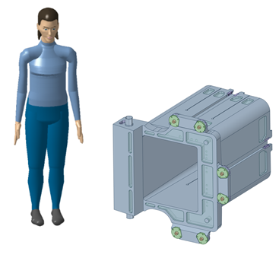
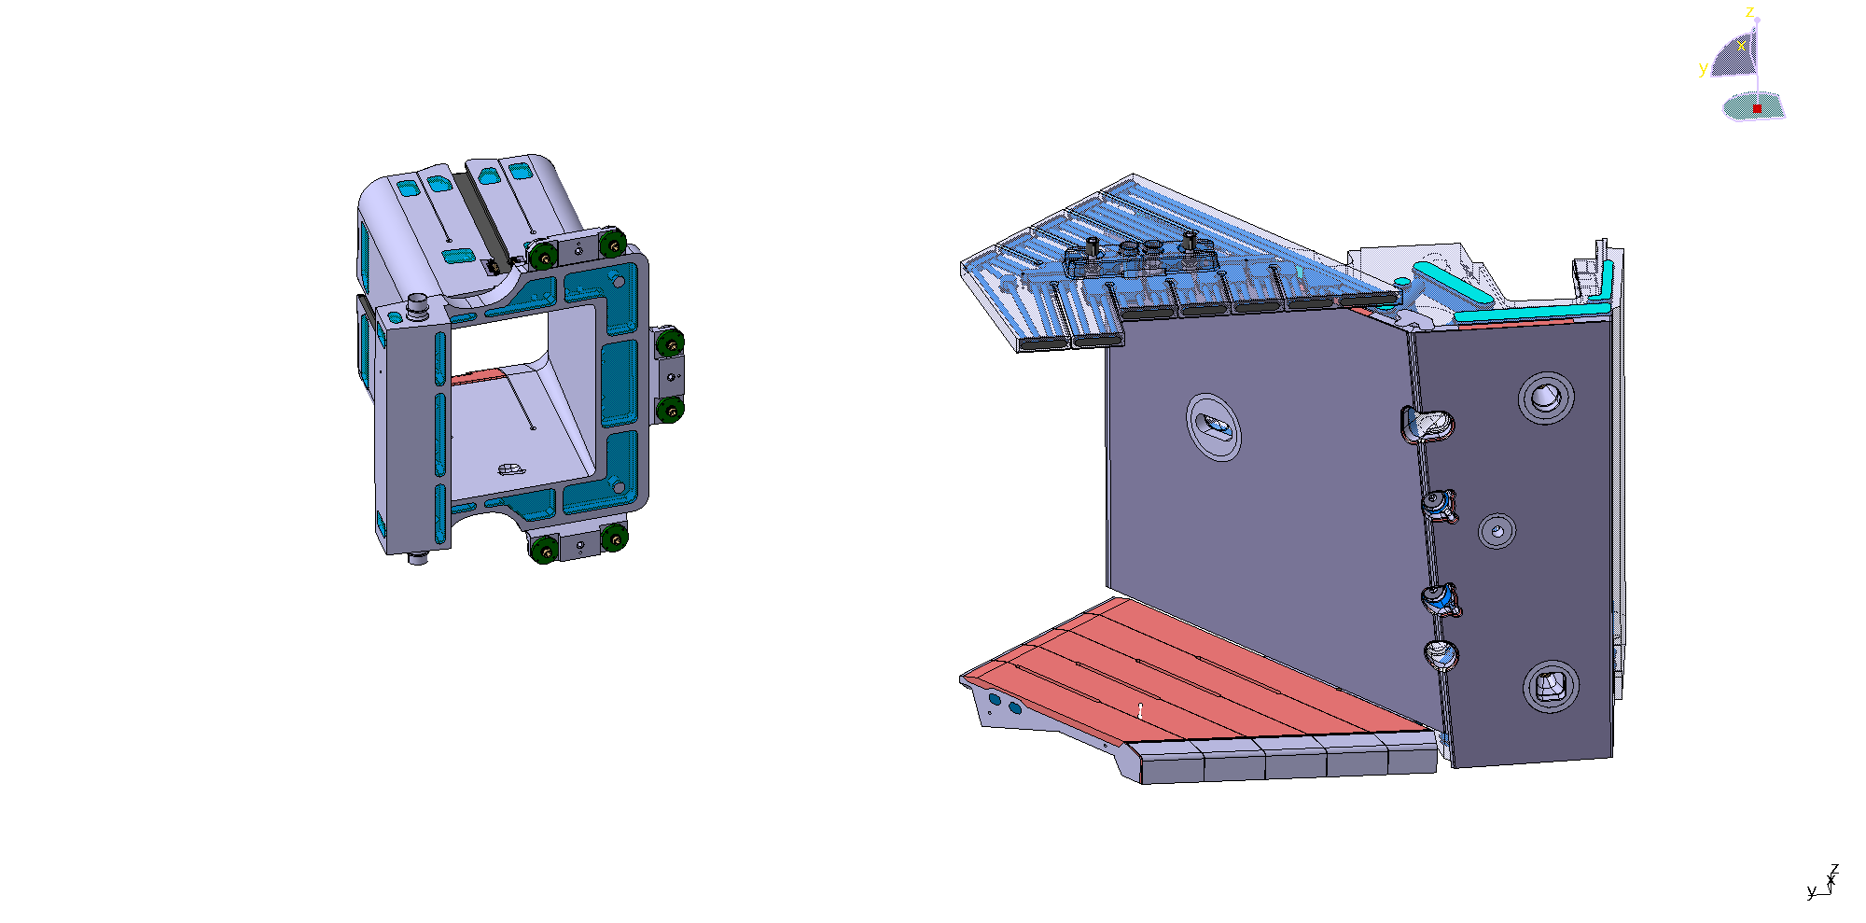
DNB Liner
HNB Plate 14
HNB Plate 16
HNB Plate 15-A & HNB Plate 15-B
Figure 5-1. Neutral Beam Port Liners

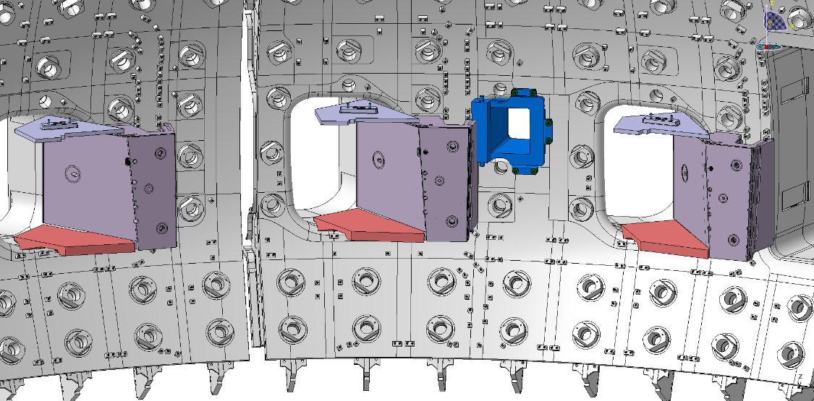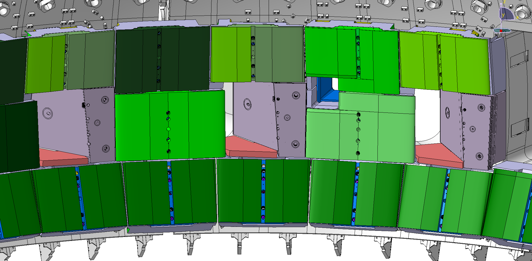
DNB Liner
HNB
Plate 14
HNB
Plate 16
HNB
Plates 15

Figure 5-2. The NBPL, located at the Neutral Beam Ports, consist of one DNB liner (in blue) and twelve HNB plates (four plates in each of the three HNB ports

HNB Plate 15-A3
HNB Plate 14NDL
HNB Plate 16DVL
HNB Plate 16BL
HNB Plate 15-B1
HNB Plate 15-A1
HNB Plate 15-B2
HNB Plate 15-A2
HNB Plate 15-B3
DNB liner
- Naming for NBPL components

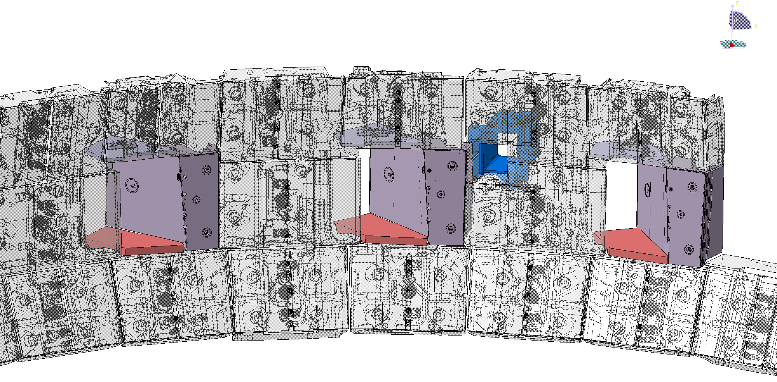
DNB liner
Integrated SB14NDL
(HNB Plate 14NDL
+ SB14NDL)
Integrated SB15NDA
(HNB Plate 15-A1
+ SB15NDA
+ HNB Plate 15-B1)
Integrated SB14NDV
(HNB Plate 14NDL
+ SB14 NDV)
Integrated SB14ND
(HNB Plate 14NDL
+ SB14ND)
Integrated SB16NB1
(HNB Plate 16DVL
+ SB16NB1)
Integrated SB16NB
(HNB Plate 16BL
+ SB16NB)
Integrated SB15ND
(HNB Plate 15-A3
+ SB15ND
+ HNB Plate 15-B3)
Integrated SB15NDB
(HNB Plate 15-A2
+ SB15NDB
+ HNB Plate 15-B2)
- Naming for NBPL and Integrated SB
Figure 5-3. List of NBPL components and Integrated Shield Blocks

The detailed model of the NBPL is stored in Enovia database, referring details in the Bill of Materials for the NB Port Liners (16.NL) [AD4].

Table 5-1 Classification of NBPL components

Sub-components Description | Quality Class | Vacuum Class | PIC /PIA | PED /ESPN | Seismic Class | RH Class | Design Code | Tritium Class
DNB Liner | QC1 | VQC 1 | No | No | SC2 | Class3 | SDC-IC [CS1] | No
HNB Plates | QC1 | VQC 1 | No | No | SC2 | Class2 | SDC-IC [CS1] | No
Integrated Shield Blocks | QC1 | VQC 1 | No | No | SC2 | Class3 | SDC-IC [CS1] | No

DNB Liner
The DNB liner consists of a 60mm thick flange on the Blanket Shield Block side and a 40mm thick on the Vacuum Vessel side. The DNB liner is a stainless-steel component with internal cooling in the form of deep drillings and milled water boxes with welded covers. The back end of the DNB liner includes deep slits. A small portion of the component includes 3mm CuCrZr layer, which to be manufactured as a separate HIP’ed part that is subsequently welded to the DNB structure via a through-thickness full penetration weld (e.g: Electrical Beam welding).
The DNB liner includes interfaces for gripping and manipulation on the inner surfaces of the component. In addition, back-up handling interfaces are including in the form of three tapped holes near the VV rail attachment points.
The DNB liner is mechanically fixed to the Vacuum Vessel via six M14 Bolt Assemblies and eight PAD Assemblies, where some Standard Parts coated with Electrical Insulation Coating or Copper Anti-seizing Coating.
[REQ-13] The DNB slot and the M14 Bolt Assembly shall be manufactured or customized according to As-Built data from VV Sector 02.
[REQ-14] Before manufacturing or customization, some part of M14 Bolt Assembly shall be paired and marked.
[REQ-15] After customization, some part of M14 Bolt Assembly shall be coated with Insulation Coating or Copper Anti-seizing Coating, as shown in Figure 5-7.
[REQ-16] The M14 Bolt Assembly, where interfacing with VV rails, shall be delivered separately.
The M14 Bolt Assembly will be installed to DNB liner before assembly of DNB Liner to the VV, which is out of scope.
[REQ-17] After manufacturing or customization, the DNB slot will be coated with Low Friction Coating or Anti-seizing Coating.
The type of coating (or layer) will be decided after IO assembly trials.
[REQ-18] The DNB PAD Assembly shall be manufactured according to the height of delivered spring washer at free status.
[REQ-19] Some part of PAD Assembly shall be coated with Insulation Coating or Copper Anti-seizing Coating, as shown in Figure 5-6.
The precise distance between two paired PAD assemblies is provided by manufacturing accuracy of the pocket at DNB structure and PAD assembly.
[REQ-20] The DNB Liner shall be delivered with the PAD Assemblies installed via bolt to self-lock insert on DNB structure.

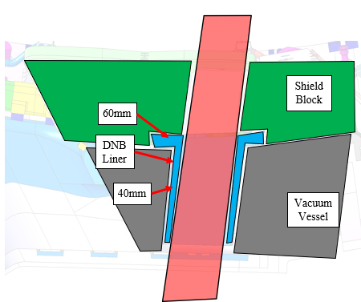
a. Scale of the DNB liner (890mm×830mm×810mm)
b. Cartoon of the function and shape
(DNB Liner: Blue)
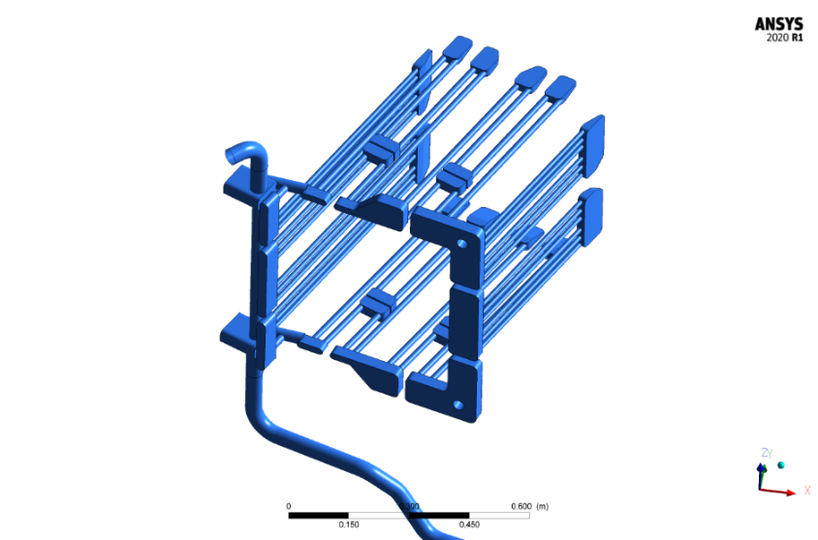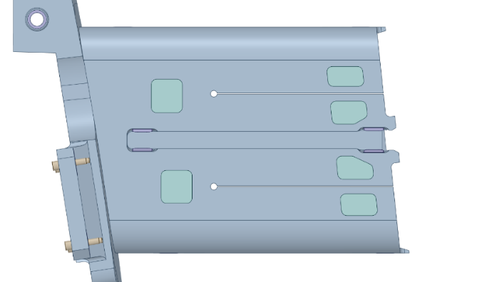
c. Slits in DNB liner to reduce eddy current flow
d. Cooling Volume Overview
(Deep drilling holes and welded covers)
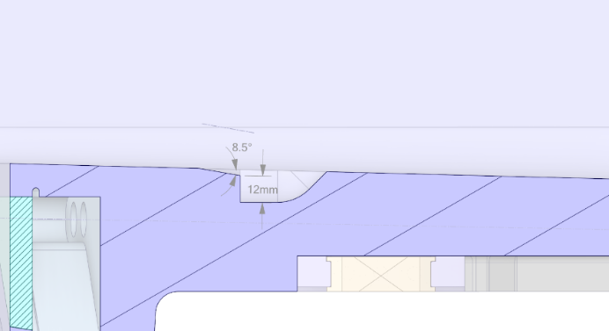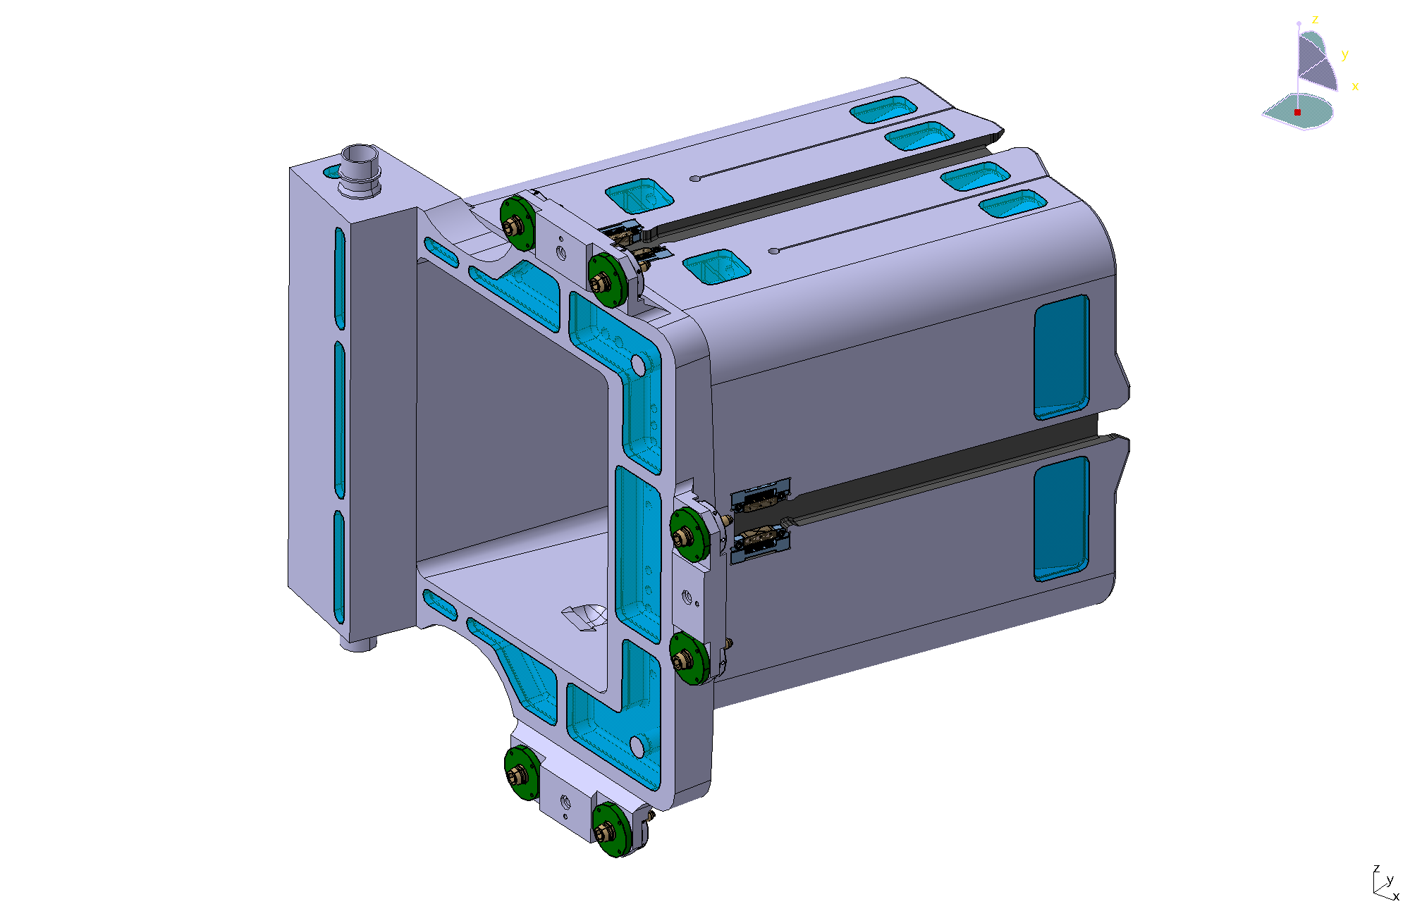
e. Handling features on DNB liner
Figure 5-4. Diagnostic Neutral Beam liner (for information only)

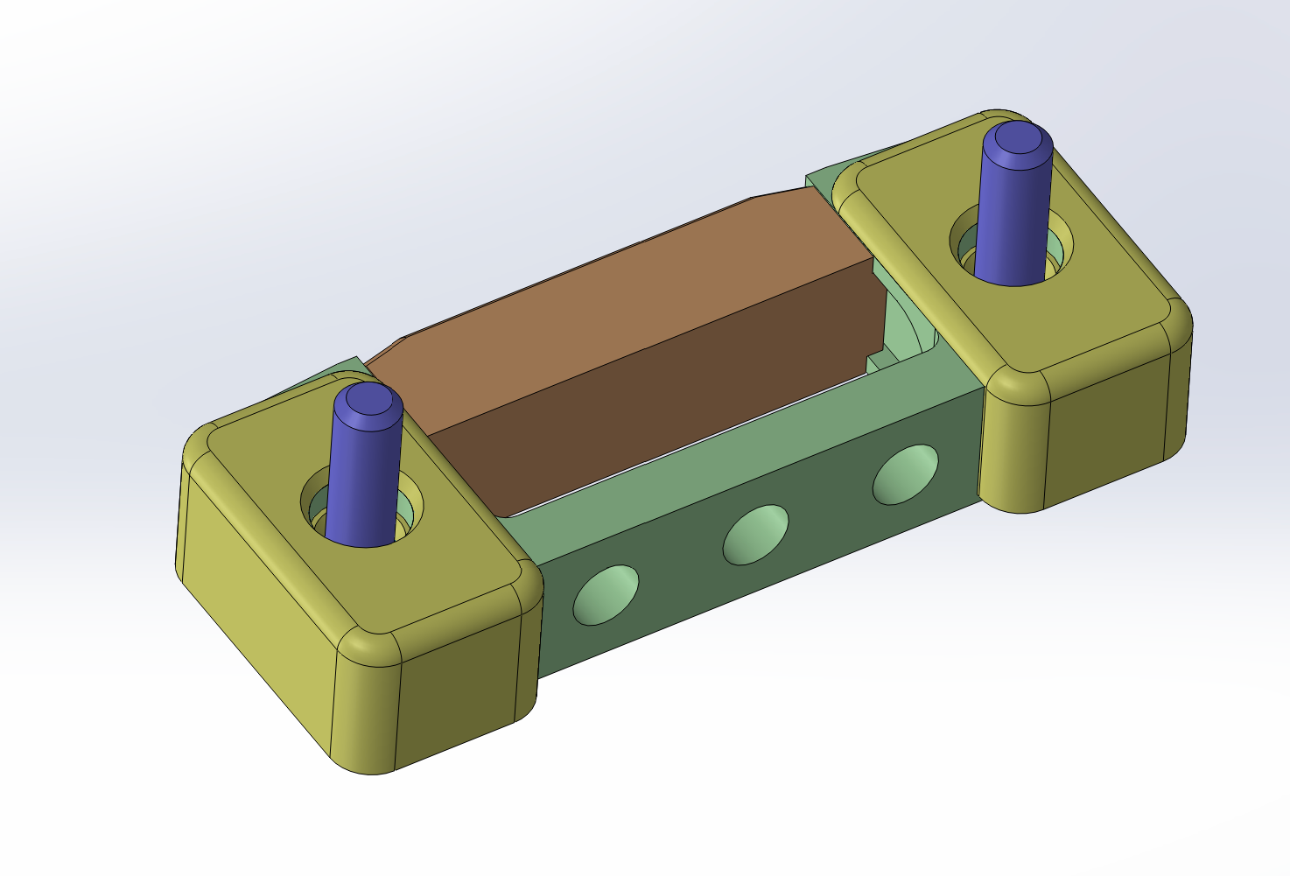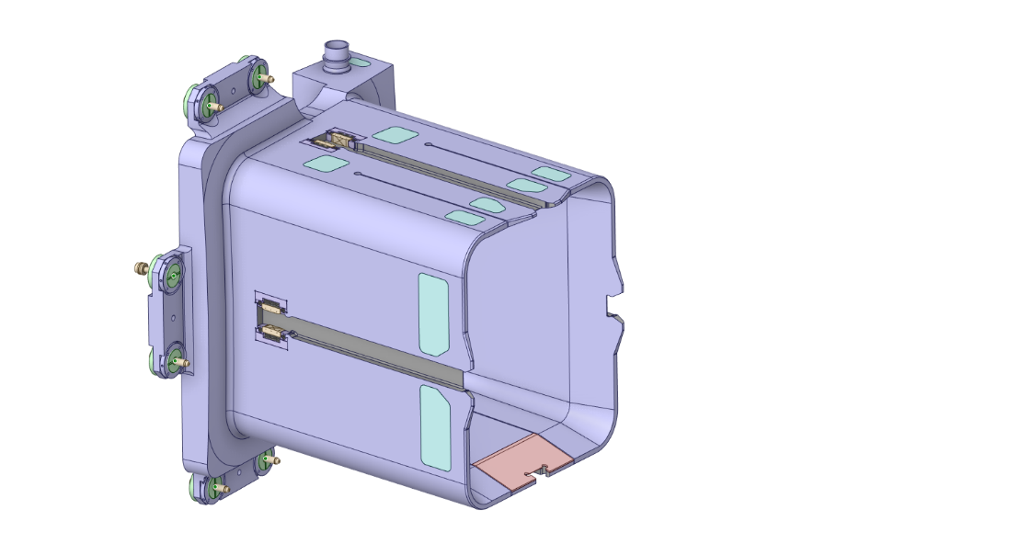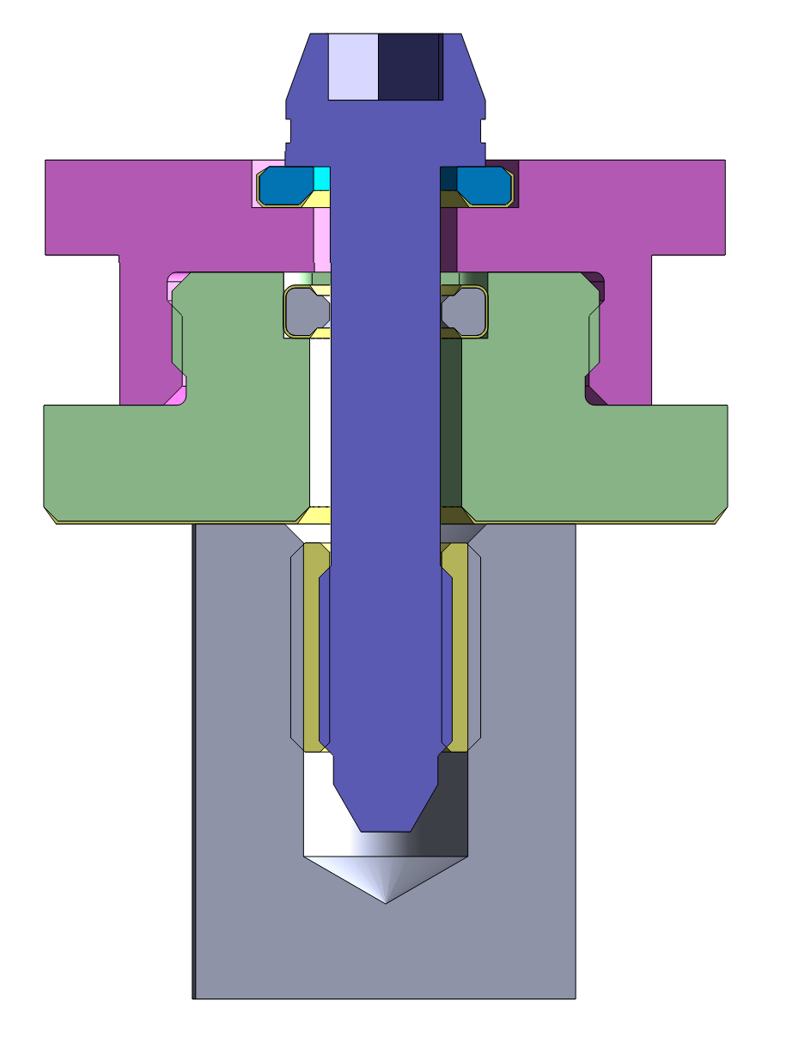
Eight PAD Assemblies
Six M14 Bolt Assemblies
Small features with 3mm CuCrZr layer
Figure 5-5. DNB Liner and its Standard Parts (for information only)

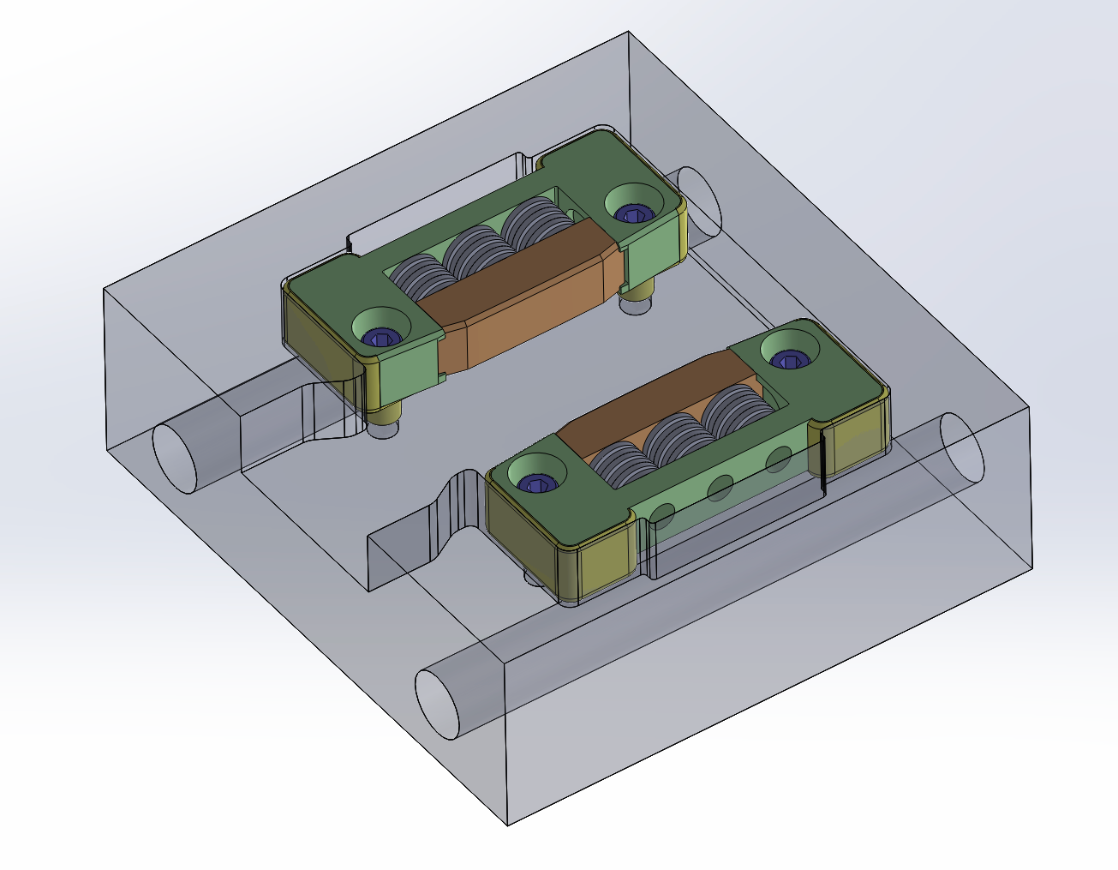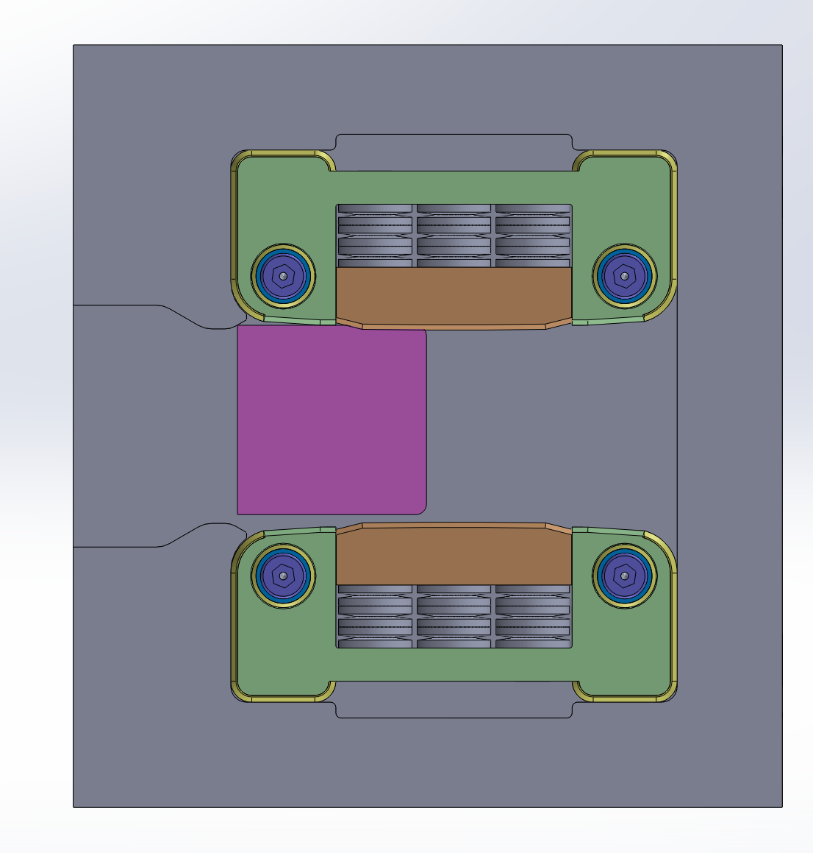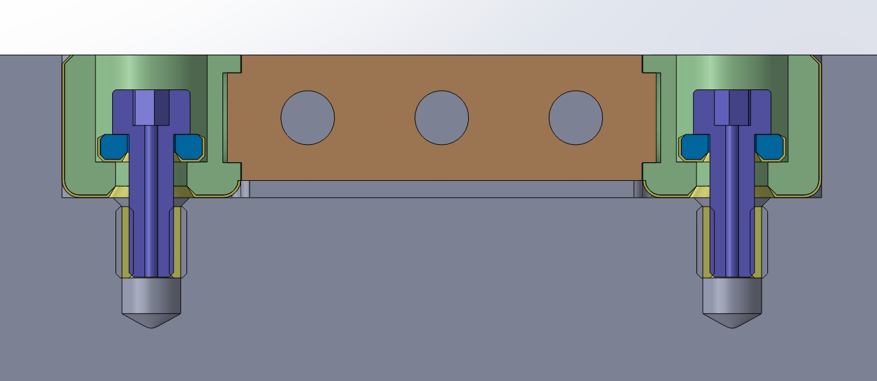
Anti-Seizing Coating [AD19]
Insulation Coating [AD20]
Figure 5-6. Detail of DNB PAD Assembly that interact with the VV shear keys (for information only)
(Insulation coatings are needed where marked by yellow and Anti-seizing coating where marked by red. The DNB Pad Assemblies shall be supplied with coatings)
Thread M14
Captive insulation washer
Insulation washer
M14 BOLT
Anti-Seizing Coating [AD19]
Insulation Coating [AD20]
Figure 5-7. Detail of DNB M14 Bolt Assembly that interact with the VV rails (for information only)
(Insulation coatings are needed where marked by yellow and Anti-seizing coating where marked by red. The DNB M14 Bolt Assemblies shall be supplied with coatings. Insert and pin are out of scope, to be supplied by VV)
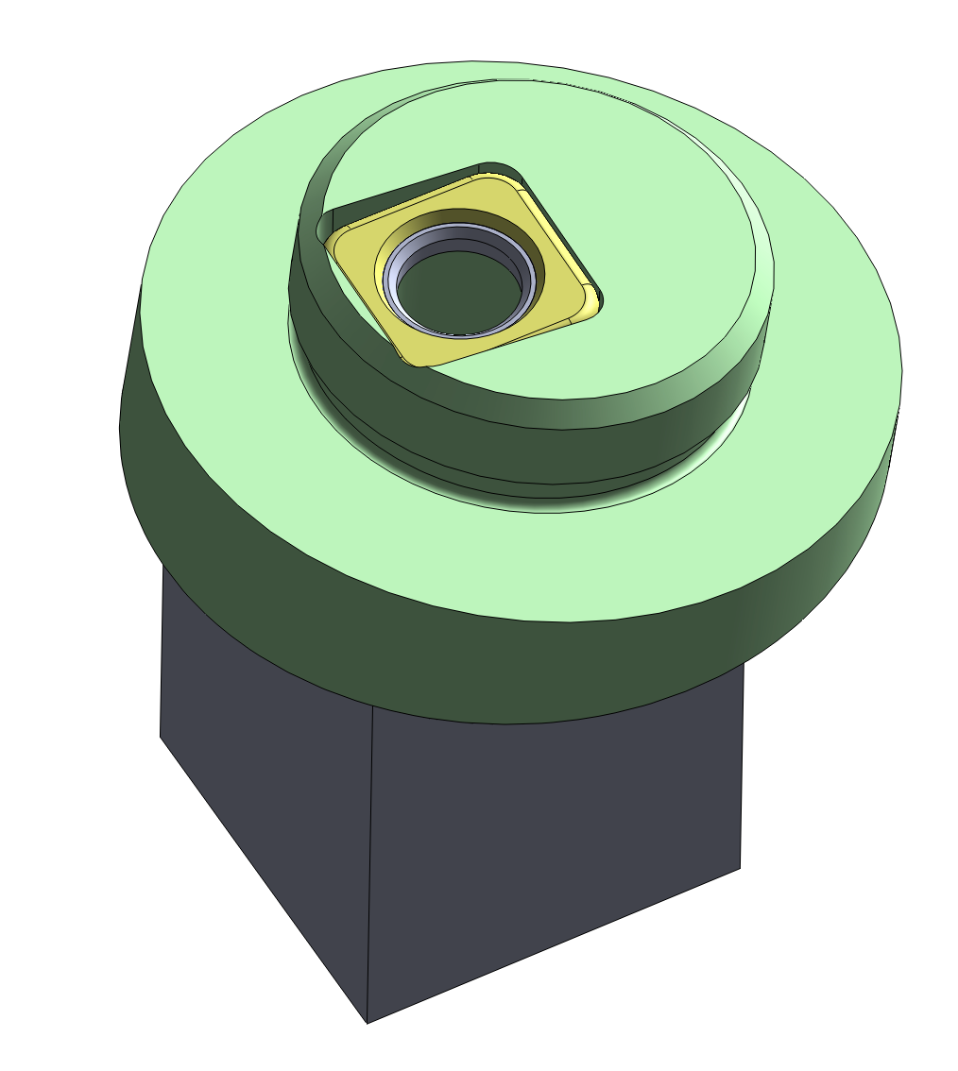
Max customization:
- ±7 GRAD
- ± 5mm lateral
- ± 2mm radial
Captive insulation washer with threaded hole of M14
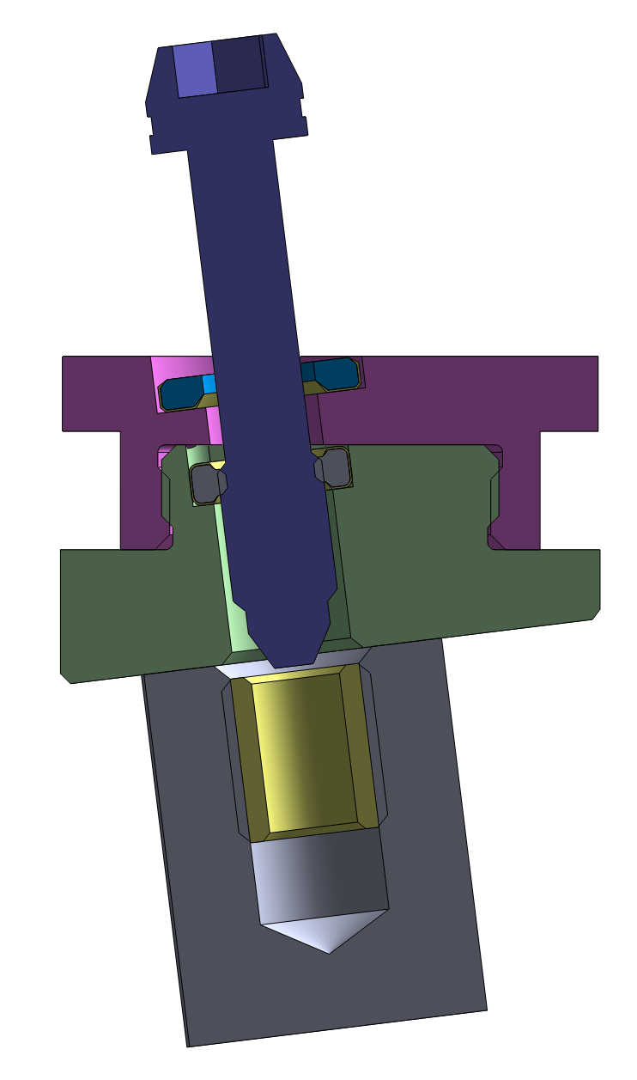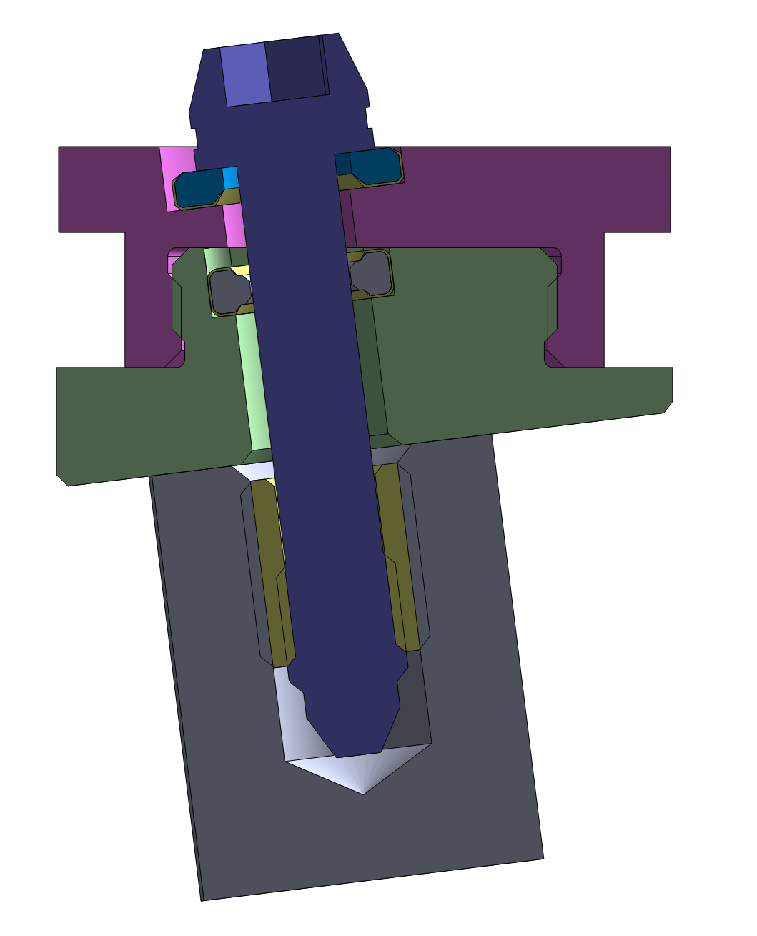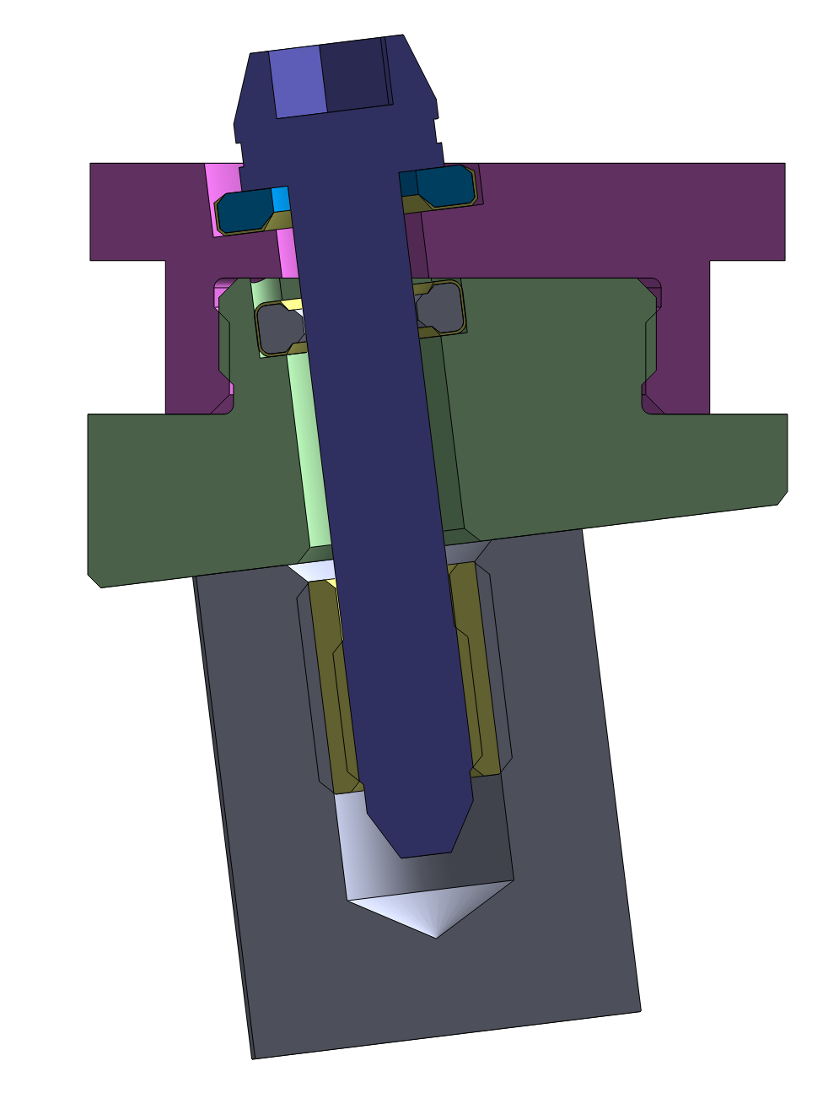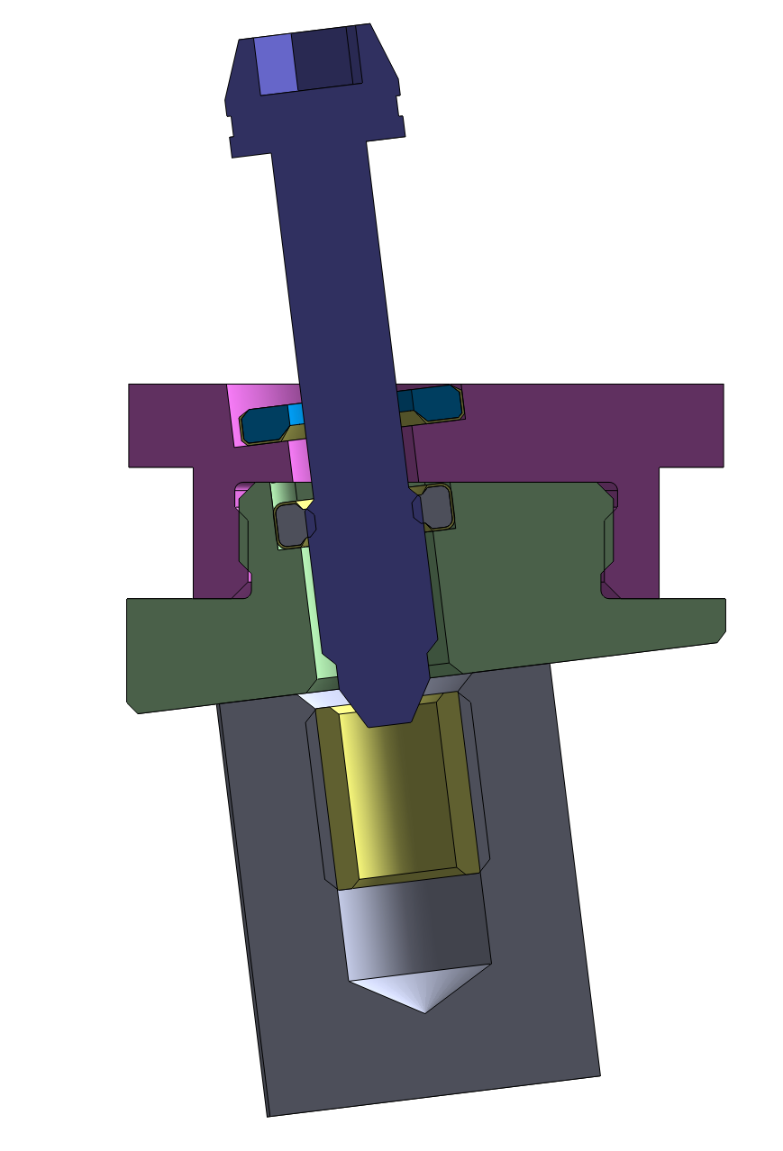
-2 mm radial
+2 mm radial
-2 mm radial
+2 mm radial
Figure 5-8. Customization capability for DNB M14 Bolt Assembly that interact with the VV rails (for information only)
(The DNB M14 Bolt Assembly shall be delivered separately without installation to DNB liner. Assembly of DNB Liner to the VV is out of scope.)
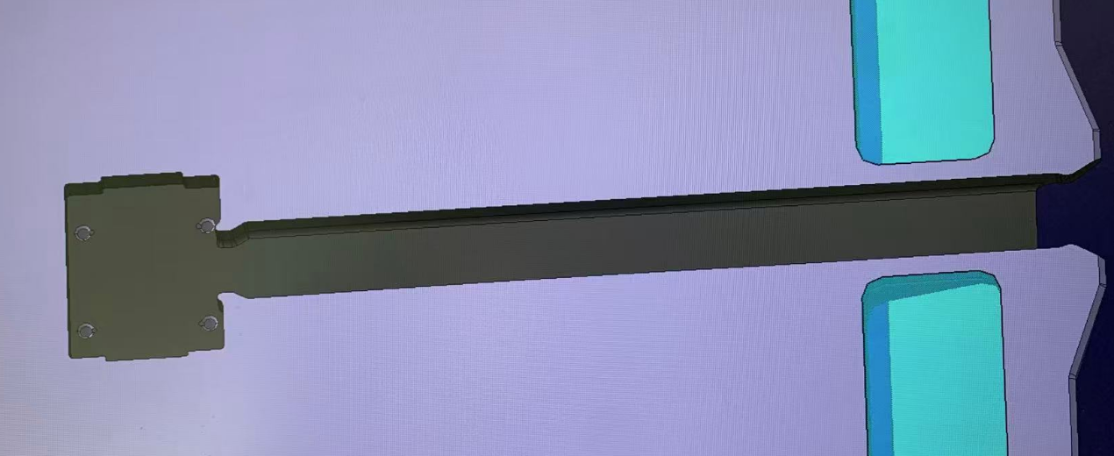
Figure 5-9. DNB slot (Keyway) to be machined according to as-built data from VV Sector#02 (for information only). Coating (or layer) may be applied on the DNB slot to be determined after IO assembly trials.

HNB Plate 14
The HNB Plate 14 is a stainless-steel component with internal cooling in the form of deep drillings and milled water boxes with welded covers.
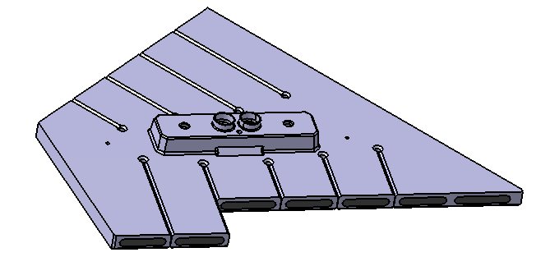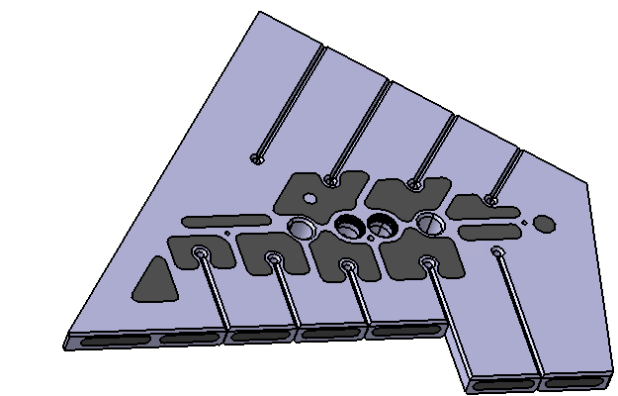
Handling holes
Key
Figure 5-10. Heating Neutral Beam Plate 14 (for information only)

The HNB Plate 14 is attached to the underside of the Shield Block 14 via welding and bolting interface. The standard parts of the Integrated SB14 include bolts, Nord Lock washers, inserts, pins and Caps, as shown in Figure 5-13. Manufacturing Caps is out of scope as they are Free Issued Item from IO.
Two bolts are inserted from the bottom and thread into inserts in SB14. The hydraulic connections are made between HNB Plate 14 and the SB14 via in bore welds between stubs on both components and finally closed by the Caps.
[REQ-21] The threads of bolts shall be coated with Anti-seizing Coating [AD8], as shown in Figure 5-14.
The center key of HNB plate 14 with tapered surface may be coated with Low Friction Coating or Anti-seizing Coating, which to be decided after Task 1 Qualification in Section 5.2.3.
The assembly interfaces on the HNB Plate 14 may be manufactured according to the as-manufactured SB to achieve required tolerances for welding and integration. The customization method and assembly process shall be developed and validated through Task 1 Qualification in Section 5.2.3.
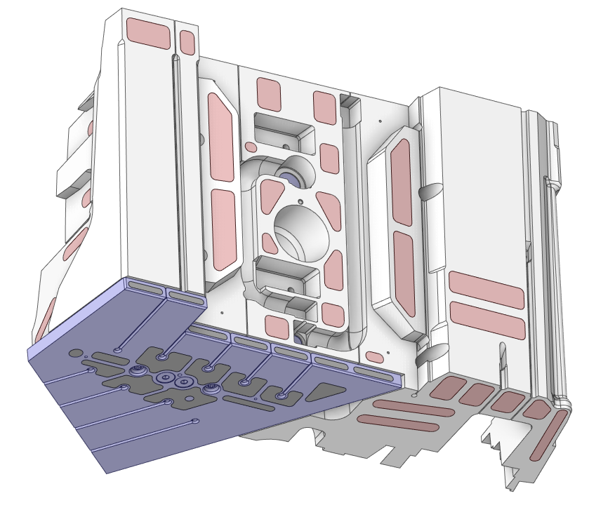
Figure 5-11. The integrated Shield Block 14 (The HNB Plate 14 attached to the bottom of SB14) (Manufacturing of SB14 is out of scope as they are Free Issued Item from CNDA)
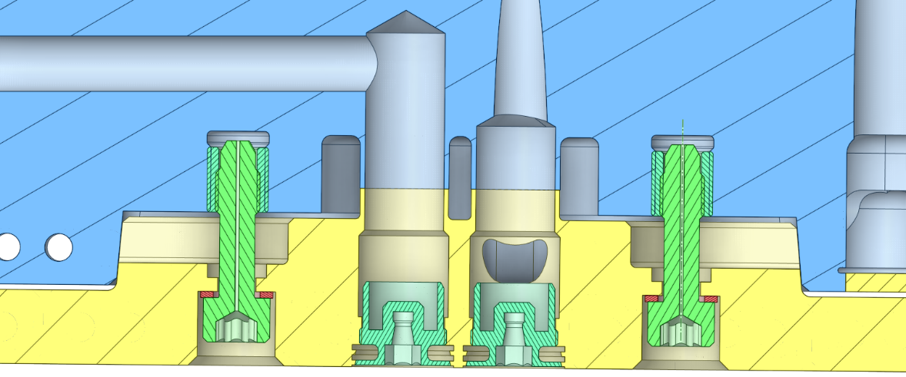
Figure 5-12. Cross section of the HNB Plate 14 to SB14 (for information only)

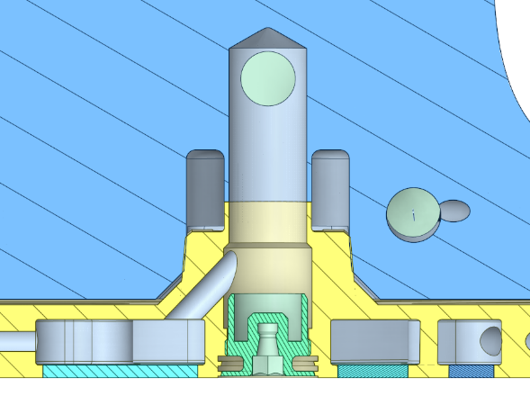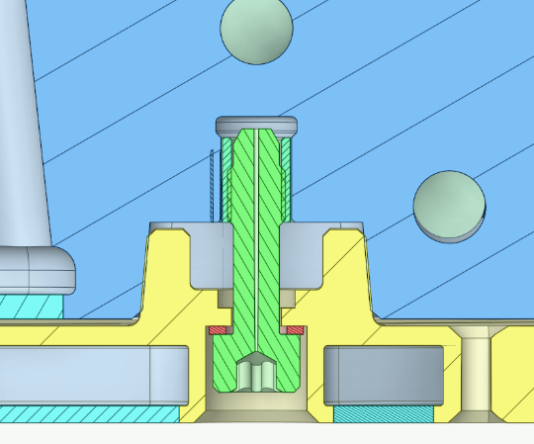
Figure 5-13. Perpendicular cross-section from Figure 5-12 at one hydraulic interface (Cap) and at one bolt interface (Bolt, Nord Lock washer, insert and pin).

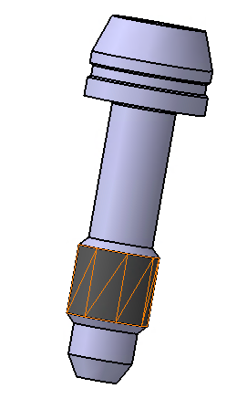
Anti-Seizing Coating [AD19]
Figure 5-14. Bolt for HNP Plate 14 applied with ASC coating

HNB Plate 16
The HNB Plate 16 consists of stainless-steel and CuCrZr which is expected to be two HIP cycles: blank CuCrZr is first bonded to steel, followed by significant machining and welding of cover plates, followed by a final HIP to join additional CuCrZr and stainless steel to the assembly. The deep drilling holes are drilled directly in both CuCrZr substrates, with a combination of water boxes and drilled holes in the stainless-steel underneath.
The HNB Plate 16 is slitted into 'fingers' on the front and back ends to minimize eddy current flow during an electromagnetic disruption event. This also permits each ‘finger’ to freely expand under thermal loads, without stress concentrations. Further reducing the flow of eddy current are grooves made between each finger to remove CuCrZr as much as possible (which has much higher electrical conductivity than steel).

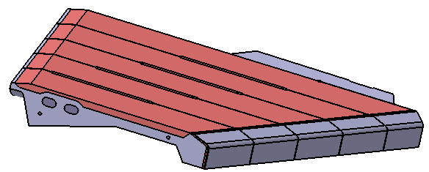
Handling holes

Top CuCrZr
SS covers
Front CuCrZr
Front SS covers
Main SS body
Figure 5-15. Heating Neutral Beam Plate 16 and its exploded view (for information only).

At the front of the HNB Plate 16, a chamfer is included to hide the extremity of the plate from the neutral beam loads. This permits the highest heat loads from the beam to fall on an area that is purely CuCrZr, without an interface to steel (with much lower thermal conductivity).
The front area is covered with 2mm thick stainless steel to prevent the exposure of Copper to the plasma for purposes of plasma impurity control.
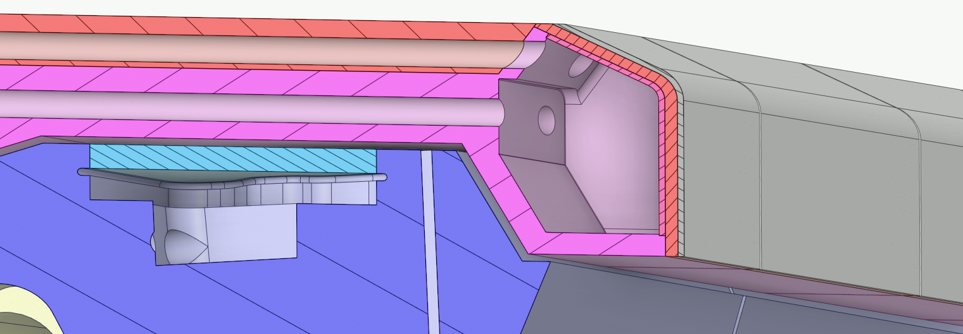
Figure 5-16. The HNB Plate 16 plasma facing area is optimized for heat transfer for the beam and plasma loads with aggressive cooling and chamfers to shadow the highest loads.
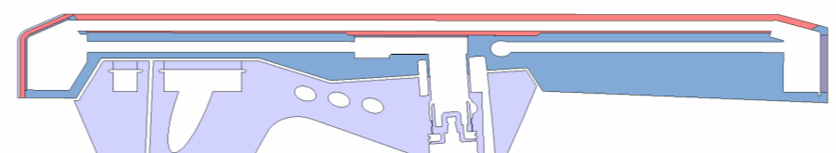
Cooling channel
(SS)
Cooling channel (CuCrZr)

Figure 5-17. HNB Plate 16 Cooling Overview (Deep drilling holes).
The HNB Plate 16 attaches to its associated Shield Block 16 via welding and bolting interface. The standard parts of the Integrated SB 16 include bolts, Nord Lock washers, inserts, pins, and Caps, as shown in Figure 5-19. There will be eight bolts pass through the back side of SB16 into the inserts in the HNB Plate 16. The hydraulic connections are made between HNB Plate 16 and SB16 via in bore welding of the stubs provided on both components (with limited access) and finally closed by the Caps. Manufacturing of Cap is out of scope as they are Free Issued Item from IO.
[REQ-22] The threads of bolts shall be applied with Anti-seizing Coating [AD8].
The axis deviation of 5 degrees exists between the hydraulic connections and the bolts.
The keys are located near the center of gravity of the HNB Plate 16 for reaction of the electromagnetic disruptions; this allows the rest of the component to expand freely without contact to the Shield Block.
The assembly interfaces on the HNB Plate 16 may be manufactured according to the as-manufactured SB to achieve required tolerances for welding and integration. The customization method and assembly process shall be developed and validated through Task 1 Qualification in Section 5.2.3.

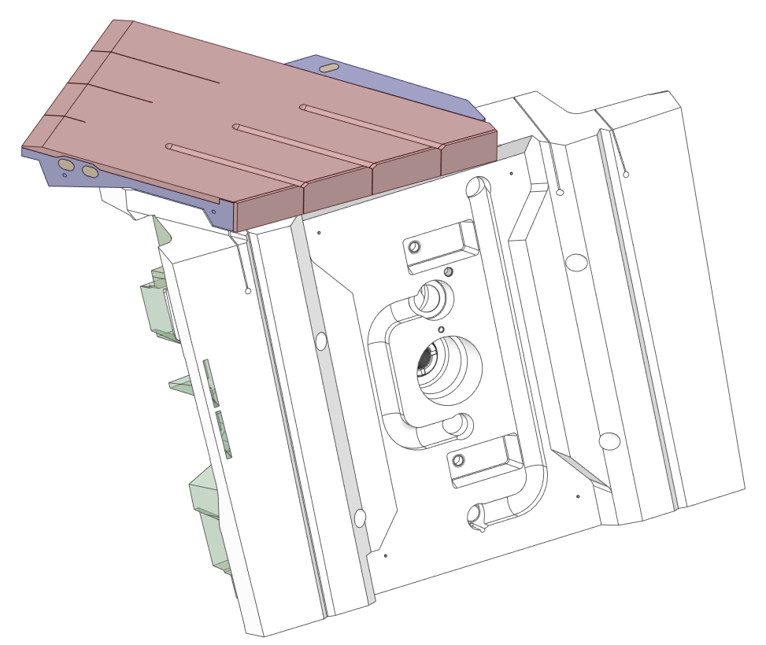
Figure 5-18. The Integrated Shield Block 16 (HNB Plate 16 attaches to the top of SB16)
(Manufacturing of SB16 is out of scope as they are Free Issued Item from KODA)

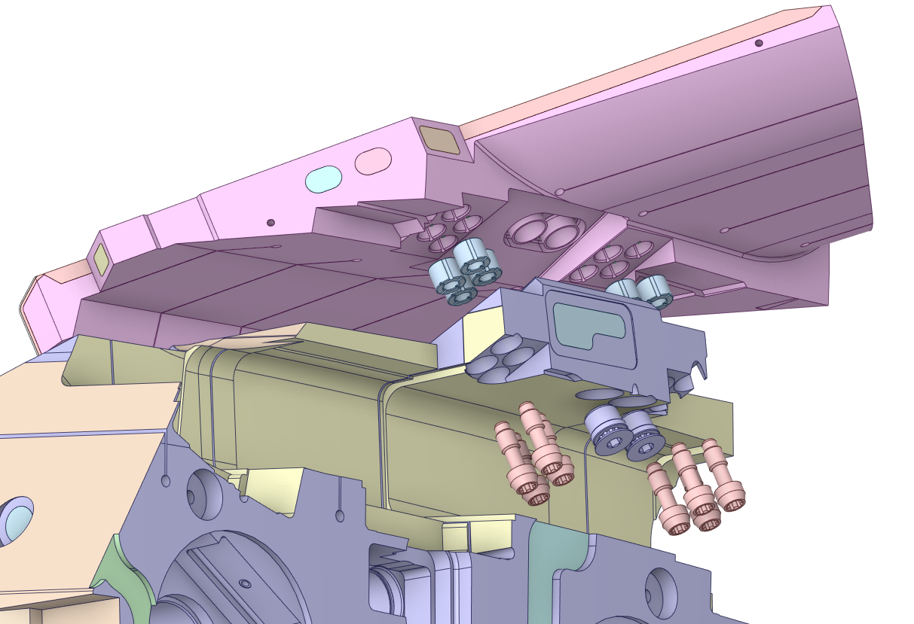
Figure 5-19. The bolts pass through the back side of SB16 into the HNB Plate 16 (the axis deviation of 5 degrees between the hydraulic connection and the bolts; the standard parts of the Integrated SB16 including bolts, Nord Lock washer, insert, pin and Caps).

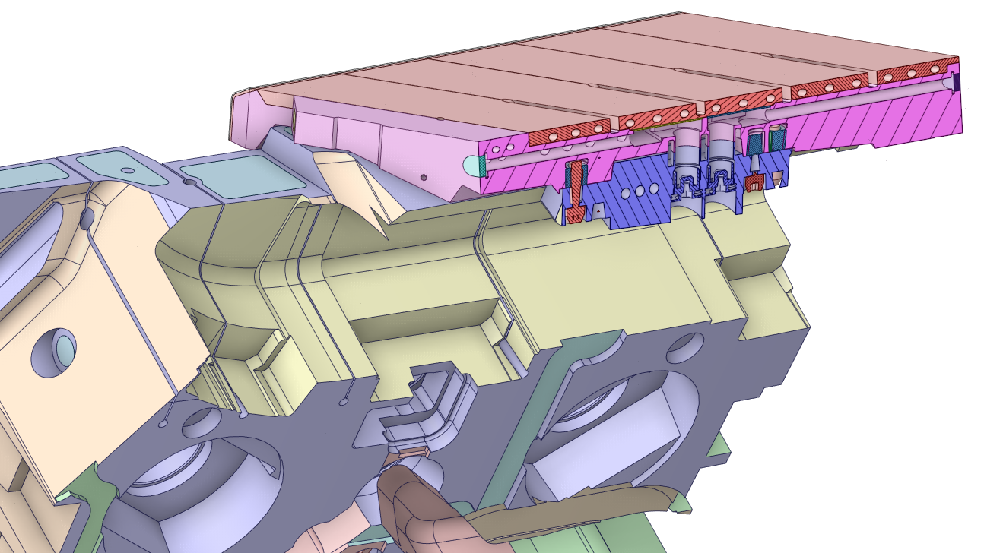
Figure 5-20. Cross section of the HNB Plate 16 to SB16 (the axis deviation of 5 degrees between the hydraulic connection and the bolts; the standard parts of the Integrated SB16 including bolts, Nord Lock washer, insert, pin and Caps)

HNB Plates 15
The HNB Plates 15 consist of stainless-steel front and back surfaces with the CuCrZr. The HNB Plates 15 are Hot Isostatic Pressed onto the Shield Block 15.
Except SB15NDS (to be used for the spare of the Integrated SB15), other SB15NDx is Free Issued Item from KODA.
After HNB Plates 15 HIPed to the SB15NDx, some water headers and covers are to be machined/welded.
Final machining shall be done on the Integrated SB15, including cutout for handling, hydraulic connection, and final outer surface, as shown from Figure 5-21 to Figure 5-24.
The standard parts of the Integrated SB15 include RH inserts and pin, self-lock inserts and pin for the interface with TIP, and Cap Long. Cap Long is out of scope, which to be supplied by IO and to be welded to the Integrated SB15 at ITER site.
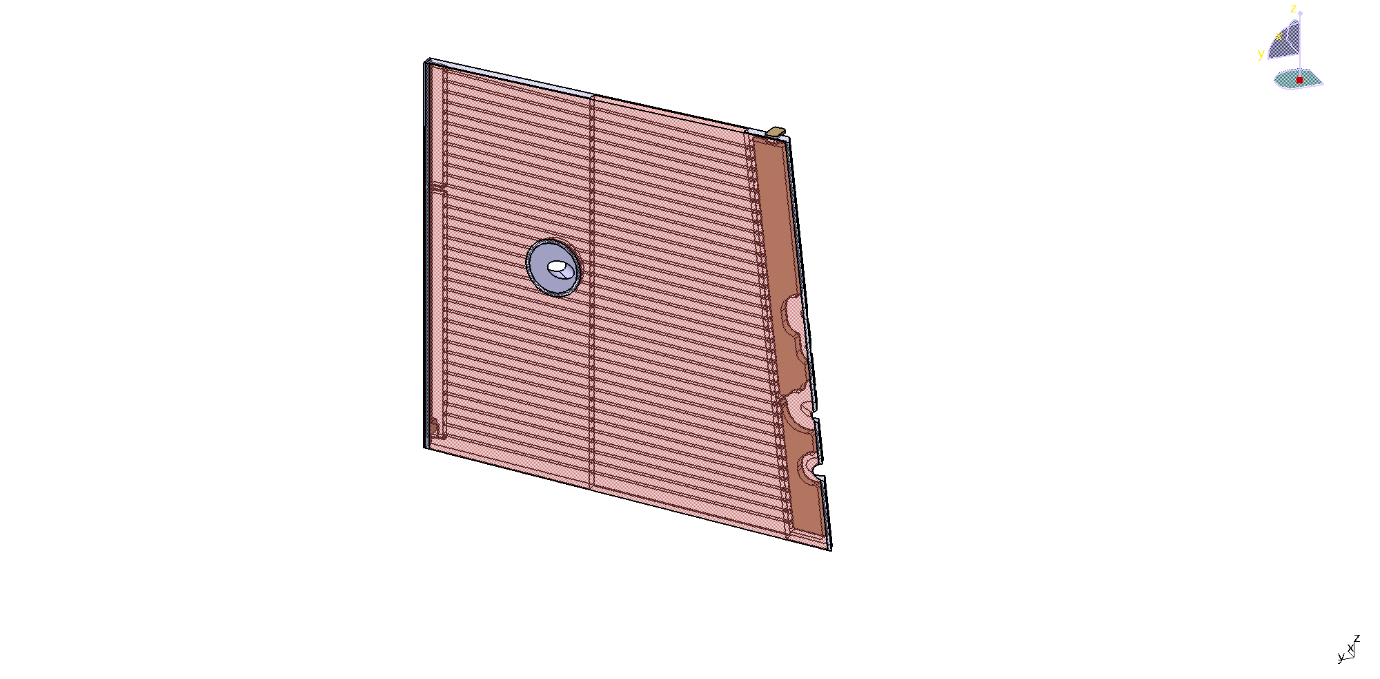
HNB Plate 15-A
HNB Plate 15-B
Figure 5-21. Heating Neutral Beam Plates 15 (SS/CuCrZr/SS HIP bonded, some cutout machined after HIP onto SB15NDx, for information only)
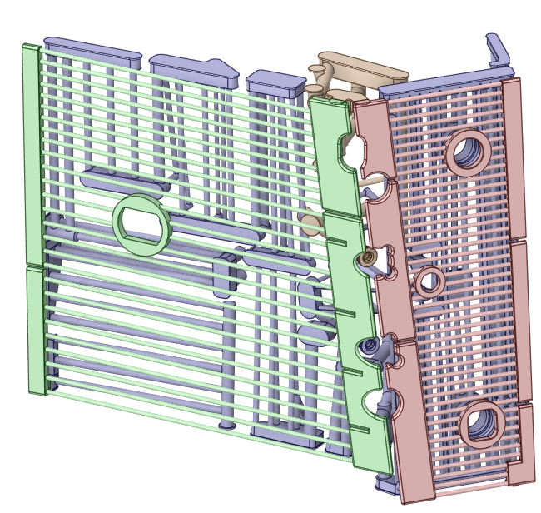
HNB Plate15-A
HNB Plate15-B
Figure 5-22. HNB Plates 15 Cooling Volume Overview (Deep drilling holes, some cutout machined after HIP onto SB15NDx, for information only)
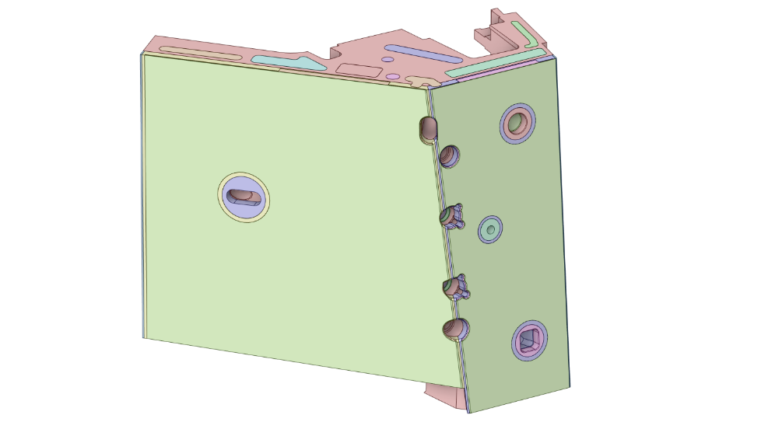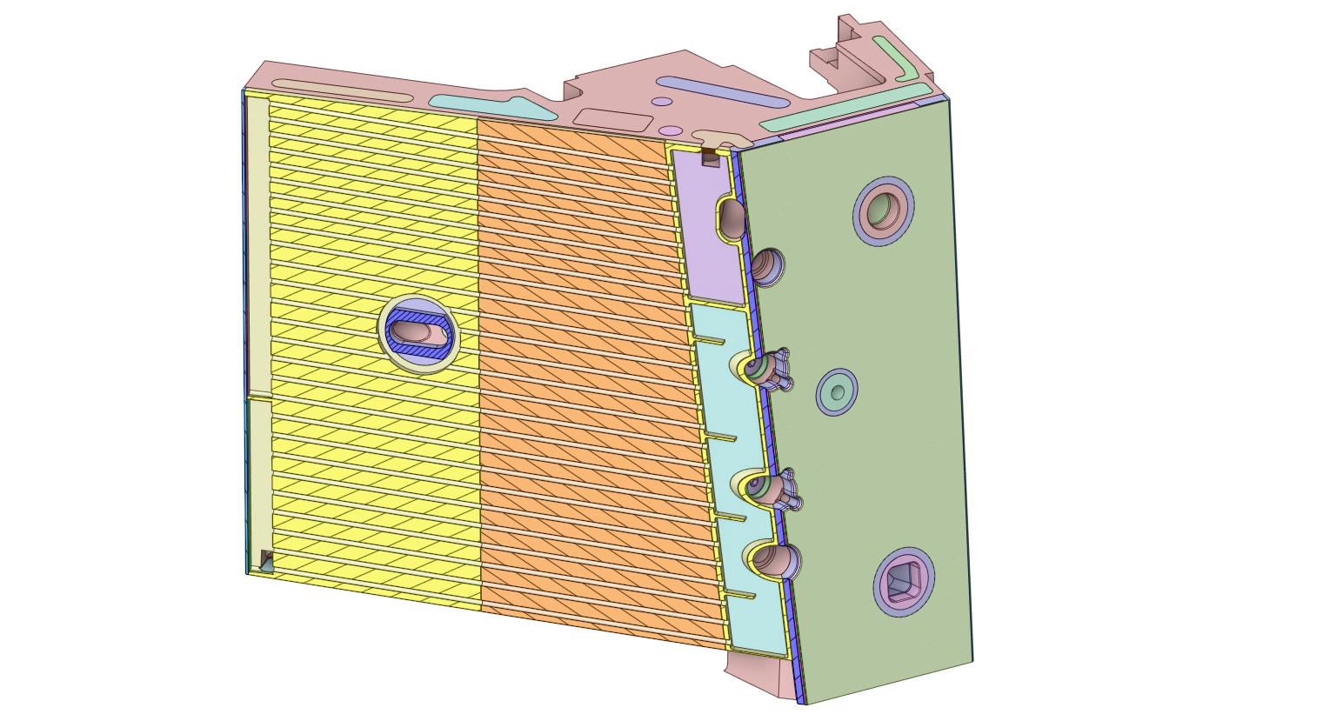
Figure 5-23. The Integrated Shield Block 15NDA (some cutout machined after HNB Plate 15 HIPed onto SB15NDx, for information only)
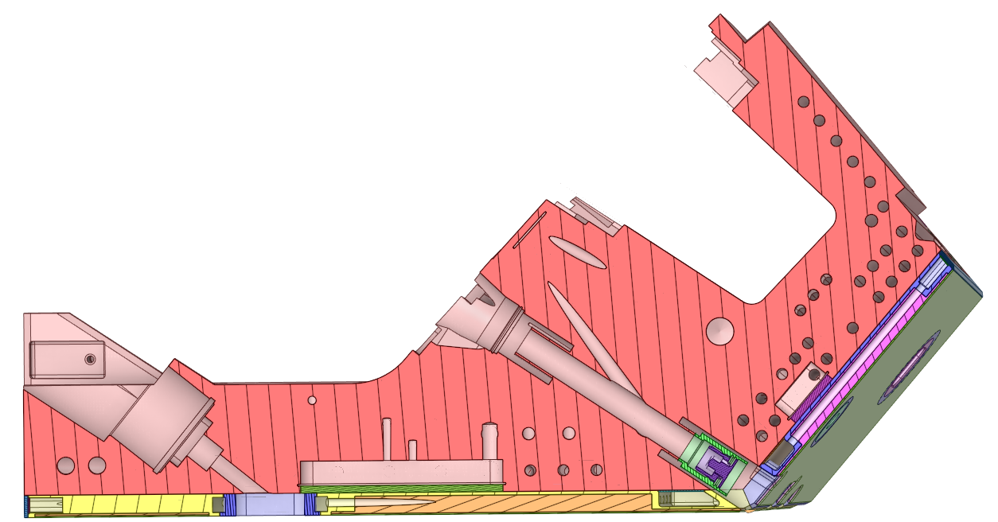

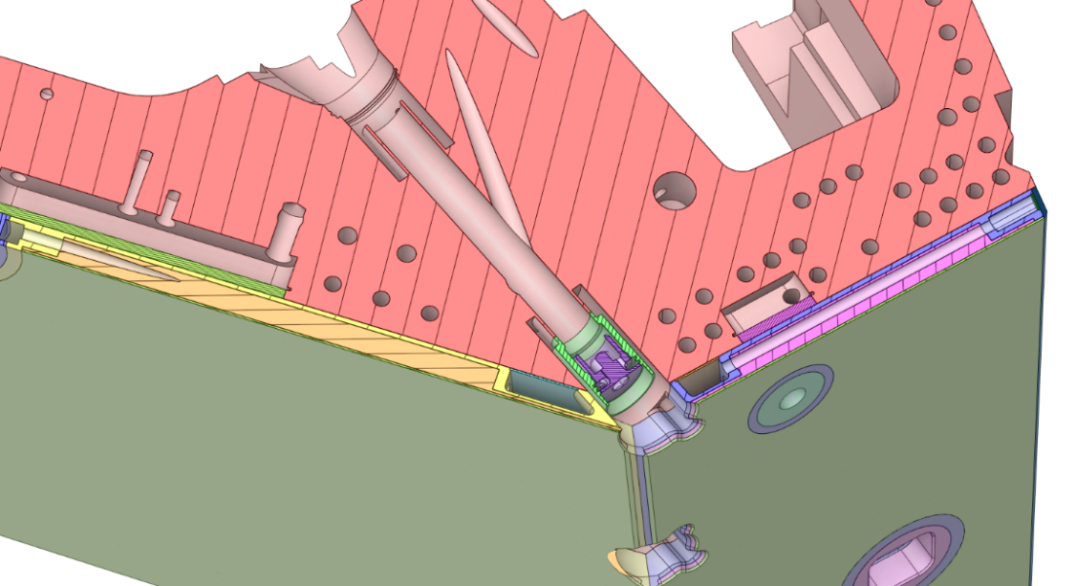
Figure 5-24. Cross-section of Integrated Shield Block 15 (some cutout machined after HNB Plates 15 HIPed to the SB15NDx, Cap Long is out of scope, which to be welded with the Integrated SB15NDx at ITER site)
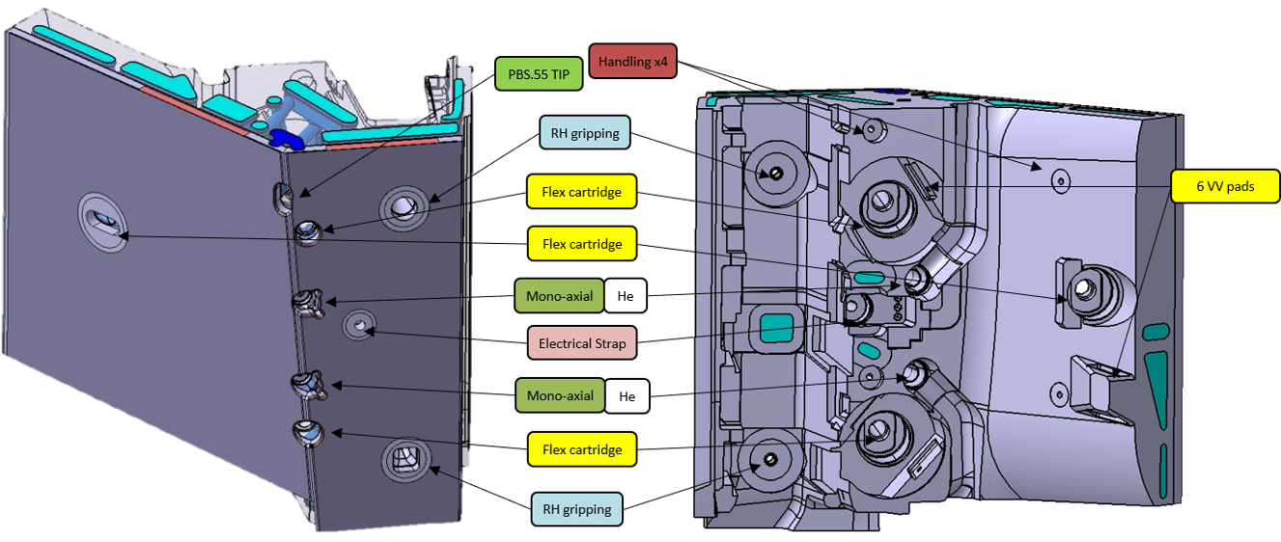
Figure 5-25. Interface on the Integrated SB15NDA (for information only)
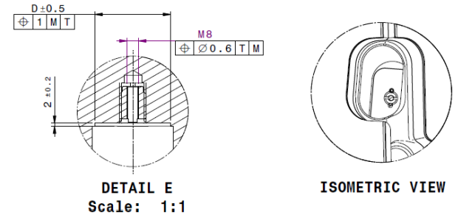
Figure 5-26. Interface with PBS 55TIP on the Integrated SB15NDA (Interface with TIP including self-lock insert and pin)

Supply Scope

Fabrication Scope
This contract will cover the manufacturing and testing of Neutral Beam Port Liners (including provisions for spares), namely:
- Diagnostic Neutral Beam Liner, qty 2
- Heating Neutral Beam Plates:
  - Plate 14, qty 4
  - Plate 15, qty 8
  - Plate 16, qty 4
- All Standard Parts (the bolts, washers, inserts, pins, etc., excluding Caps which are Free-Issued Items from IO.)
- Shield Block 15NDS, qty 1
The Shied Block 15NDS will be used for manufacturing of spare for the Integrated Shield Block 15NDx. Currently SB15NDA can be considered for cost assessment. The model of SB15NDS will be provided before series production.
[REQ-23] The manufacturing and testing of Shield Block 15NDS shall be in accordance with requirements specified in the 1.6.P1B.CN.01 Annex B [AD7] or 1.6.P1B.KO.01 Annex B [AD8].
Except SB15NDS, other SB15NDx and SB16 will be Free Issued Item from KODA; SB14 will be Free Issued Item from CNDA.

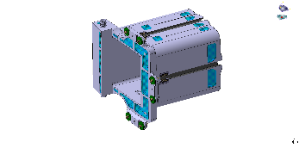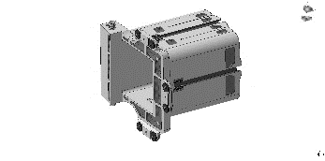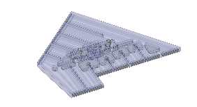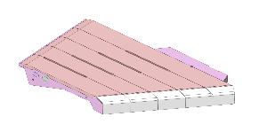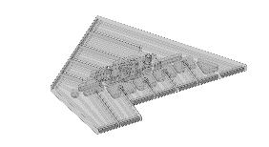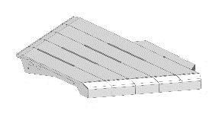
HNB
Plate 14
DNB Liner
HNB
Plate 15
+ SB15NDS
HNB
Plate 16
Figure 5-27. Quantity of NBPL components for fabrication (spares are to the right of the dotted line).

Integration Scope
This contract will also cover the integration of HNB Plates to their corresponding Shield Blocks, specifically:
- HNB Plates 15 are to be Hot Isostatic Pressed onto Shield Block 15 (see Figure 5-28).
- HNB Plate 14 is to be welded and bolted to Shield Block 14 (see Figure 5-29).
- HNB Plate 16 is to be welded and bolted to Shield Block 16 (see Figure 5-29).
Note: Except Shield Block 15NDS, all other Shield Blocks are Free-Issued Items (FII) as input to the contract.

Some final machining on SB, before or after integration with HNB Plates, is needed as part of the contract.
[REQ-24] This is the responsibility of the Contractor to protect the Shield Blocks from any damage in the integration and final machining, that relevant knowledge and sufficient R&Ds are needed to ensure the robustness of the integration processes and final machining.

For integration of HNB Plates15 with corresponding SB15NDx, the SB15NDx are supplied with half machining only, providing cooling channels and flat surface for HIPing of HNB Plates 15.
[REQ-25] After HNB Plates 15 HIPed to the SB15NDx, some cooling channel, water headers and covers shall be machined/welded.
[REQ-26] The Contractor shall be responsible for final machining of Integrated SB15NDx, including cutout for handling, hydraulic connection, interface for in vessel assembly, and final outer surface.
[REQ-27] The HIP process shall be qualified for both joint performances and deformations control through Task 1 Qualification in Section 5.2.3.
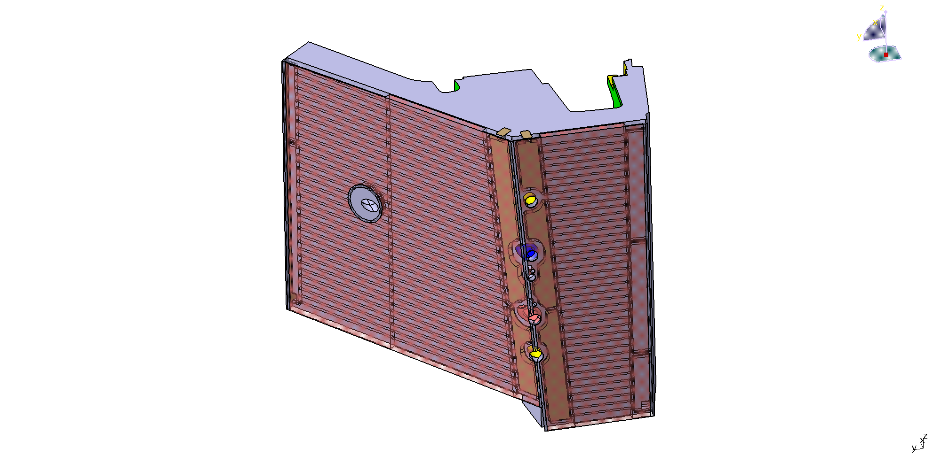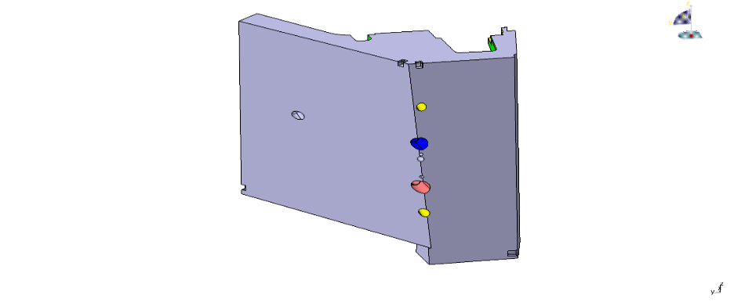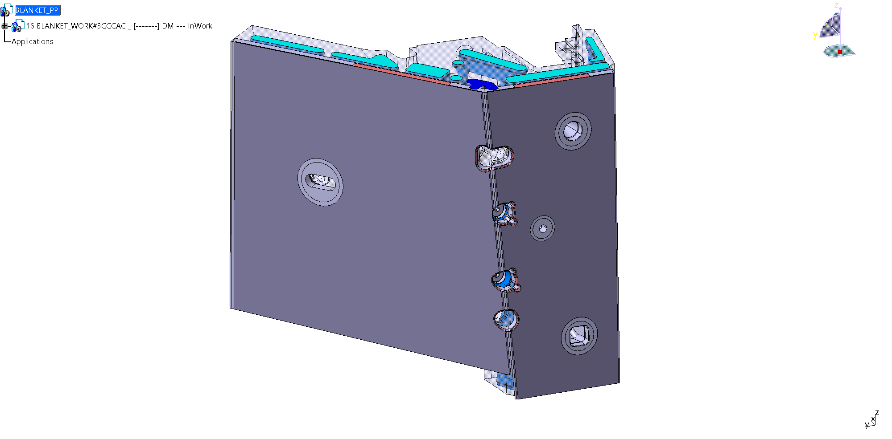
SB 15NDx with machined flat interface surfaces.
SB15NDx (Half machining)
HNB
Plate 15-A
HNB Plate 15 (CuCrZr/SS HIP bonded) with machined flat interface back surface.
HNB Plate 15 (CuCrZr/SS HIP bonded) with machined flat interface back surface.
Final HIP cycle combines all three parts (SB15NDx + two of HNB Plates 15) + final manufacturing.
The integrated SB15NDx
(1240mm×1220mm×990mm)
HNB
Plate 15-B

Figure 5-28. Integration with HNB Plates 15 and SB15NDx via HIP (for information only)
For integration of HNB Plates14 or 16 with corresponding SB, both SB14 and 16 are supplied by SB Procuring DA with its final geometry.
Referring to [RD12] PCR-808 Custom Machining on a need basis of the small cut-outs at the back of the Blanket Shield Blocks, the Contractor may perform locally the cut-outs on backside (where interfacing with VV) of SB14 and/or SB16, where needed, once the survey of the full Vacuum Vessel has been completed. The customization on backside of SB14 and/or SB 16 shall be done before integration of HNB Plate 14 and/or 16.
The assembly interfaces on the HNB Plates may be manufactured according to the As-manufactured Shield Blocks to achieve required tolerances for welding and integration. The customization method and assembly process shall be developed and validated through the Task 1 Qualification in Section 5.2.3.

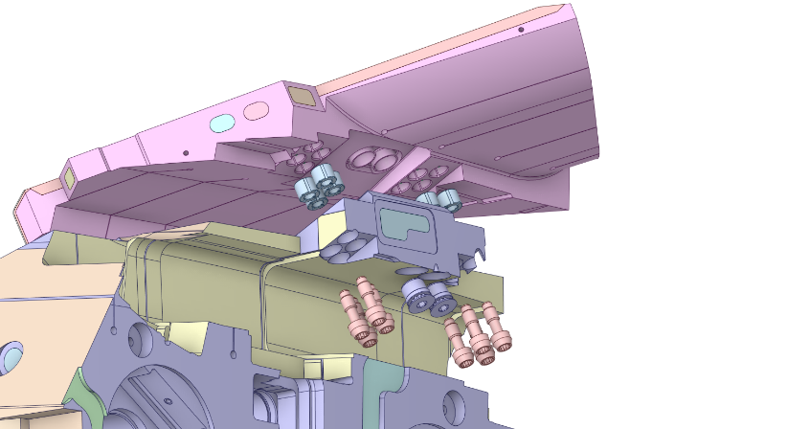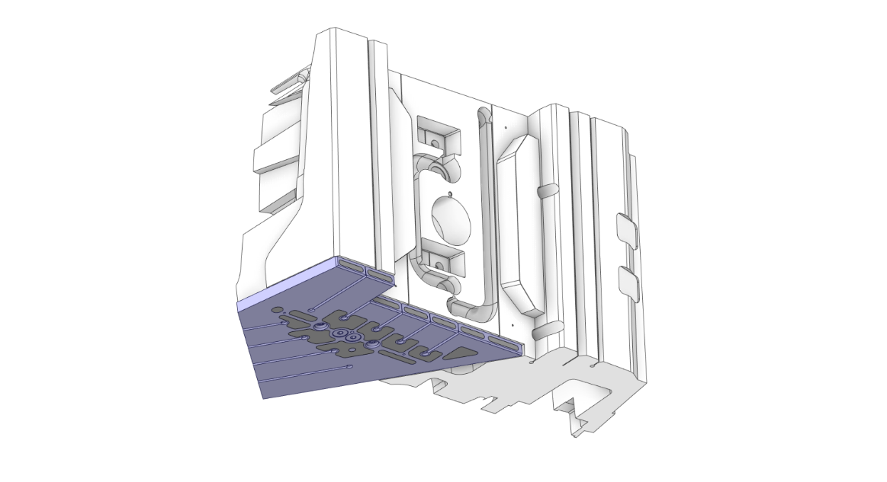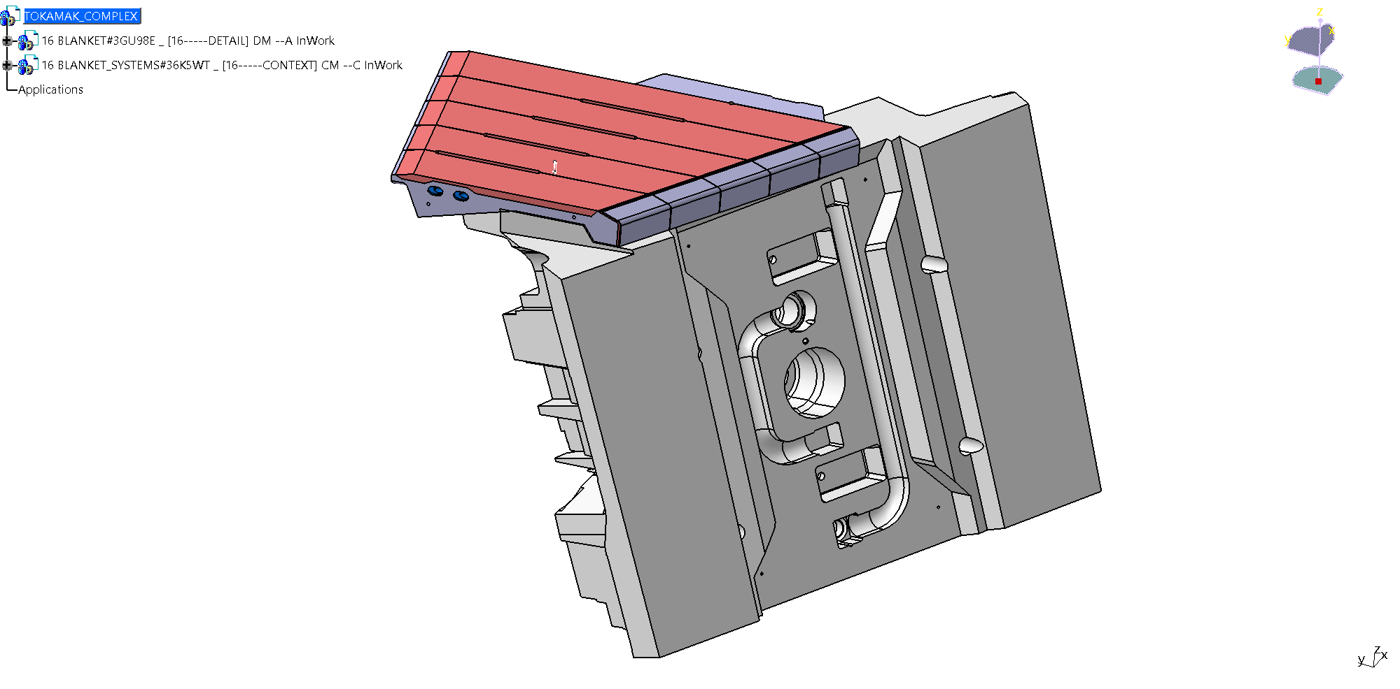
Integrated SB14
(Integration of Shield Block 14 and HNB Plate14)
Integrated SB16
(Integration of Shield Block 16 and HNB Plate16)
Key (Wedge contact)
2.5mm stub for welding to SB
Bolt
Inserts
Figure 5-29. Integration of HNB Plates 14&16 to corresponding SB via welding and bolting interface (for information only)

Contract Execution
To mitigate manufacturing risks, this contract will include two Tasks during contract execution:
- Task 1 Qualification, including design, manufacturing, testing and reporting below mock-ups:
- Mock-up for Integrated SB15 (HNB Plate 15 integrated to SB15)
The two steps HIP planned for manufacturing and integrating HNB Plates 15 to Shield Block 15, a more than 1/3 mock-up can be considered for qualification of HIP process.

- Mock-up for Integrated SB14 (HNB Plate 14 integrated to SB14)
At least one mock-up will be used for qualification of the welding and bolting interface between the HNB Plate 14 and corresponding Shield Block 14, including control of welding deformation, demonstration of welds repair, and confirmation the coating need for key of HNB Plate 14.

- Mock-up for Integrated SB16 (HNB Plate 16 integrated to SB16)
At least one mock-up will be used for qualification of the welding and bolting interface between the HNB Plate 16 and corresponding Shield Block 16, including simulation the limited welding access, control of welding deformation, and demonstration of welds repair.

- Task 2 Production, including manufacturing, testing, packaging and delivery of below components:
- Diagnostic Neutral Beam liner,
- Heating Neutral Beam plates,
- All Standard Parts (the bolts, washers, pins, etc.), and
- SB15NDS (spare for the Integrated Shield Block 15NDx)
- Integration of HNB Plates to corresponding Shile Blocks, including HNB plate 14/15/16.

Task 1 Qualification_1a
Concerning mock-up for HNB Plate 15 integrated to SB, the manufacture process is to include 2 steps HIP cycles and fast cooling (quench) anneal heat treatment to restore the properties of base materials. In these thermal cycles, the cooling channels (including CuCrZr and SS) are already made and to be exposed to the HIP working gas and need protection in the post HIP heat treatment. The cooling channels also create non-uniform mass distribution and structure discontinuity, which raises difficulties to control the deformation and to protect cooling surface from oxidation in the thermal cycles.
[REQ-28] The Contractor shall design the mock-up to represent the Integrated SB15 NDA.
[REQ-29] The Contractor shall develop the HIP/heat treatment process to be applied in the qualification and later in the production.
[REQ-30] The process shall be qualified according to the qualification procedure in Appendix A1 - Qualification of Hot Isostatic Pressing for CuCrZr to Steel and Steel to Steel bonds.
[REQ-31] The qualification shall also include test coupons for different type of HIP joint (CuCrZr/SS and SS/SS, if it appears in the product). There will be 1 production test coupon, 4 tensile test coupons (2 for RT and 2 for 250°C) for each type of joint, and 1 oxidation test coupon, referring to Section 5.5.
[REQ-32] The Contractor shall identify the possible deformation of mock-up in the HIPs and post heat treatment. A DT procedure shall be developed associated with the mock-up design, which shall be able to track the cooling channel position changes before and after HIP/heat treatment with accuracy better than ±0.2mm.
[REQ-33] The mock-up shall be DT before and after HIPs/heat treatment according to the IO accepted procedure. The deformation data shall be reported for each concerned cooling channel and outer surface.
[REQ-34] The mechanical performance of joint and base material shall be satisfied.
[REQ-35] The oxidation and deformation shall be as less as possible.
[REQ-36] In the case oxidation exceeds requirements, a cleaning procedure shall be validated to effectively remove the excessive oxidation layers.
[REQ-37] In the case of cooling channel position change is greater than ± 2mm, the Contractor shall provide mitigation methods for IO to make improvement of the product design.

Deliverables for Task 1a mock-up for Integrated SB15:
- [REQ-38] Prior to start manufacture, the qualification protocol of mock-up for HNB Plate 15 integrated to SB shall be submitted for IO acceptance, which shall include but not limit to:
- Design of mock-up for HNB Plate 15 integrated to SB
- Description of manufacturing route, including the 2 steps HIP, post HIP heat treatment, all needed inspections, and interface/jig for hydraulic and leak test
- The preliminary procedure for HIP/heat treatment process
- The design of test coupons and their needed test, including Destructive Tests and their test procedures
- Non-Destructive Tests and their test procedures
- Procedures required for manufacturing and inspection, such as dimension inspection, cleaning, leak testing, pressure testing
- Proposal on fiducial interface to track manufacturing process and ensure the relationship of the final datums with the cooling position, and track HIP deformation and final machining amount.

- [REQ-39] After completion of all planned tests, a qualification report of mock-up for HNB Plate 15 integrated to SB shall be submitted for IO acceptance. This shall include, but not limit to:
- All manufacturing records, especially record for HIP/ post heat treatment
- All test reports, especially DT reports for tracking of deformation at different manufacturing stage such as before/or after HIP/ post heat treatment; VT report on any issues concerning possible oxidations.
- Confirming feasibility of the approach as well as any manufacturing and inspection difficulty.
- Confirming feasibility of the proposed fiducial interface for tracking manufacturing process.
- In case of non-conformance, root cause analysis and mitigation methods shall be proposed/validated.
- Lessons & learning, and recommendations for improvement of the product design.

Task 1 Qualification_1b +1c
[REQ-40] Concerning mock-ups for HNB Plate 14/16 integrated to SB, the interface between HNB Plate 14/16 and SB includes both bolting and welding joints. The Contract shall design and manufacturing two mock-ups, one is to represent the Integrated SB14, and another one is for the Integrated SB16.
- Concerning mock-up for the Integrated SB14, zero gap is designed between tapered key on HNB Plate 14 and corresponding SB14. The alignment of pipe ends for bore welding is determined by the tapered key surfaces contacting with preload. During insertion or removal of HNB Plate 14 from SB14, check and confirm if coating required on the key with tapered surface, such as low friction coating or anti-seizing coating.
- Concerning mock-up for the Integrated SB16, the axis deviation of 5 degrees between the hydraulic connection and the bolts, with limited access for welding and bolting.

The interface parts on HNB Plate 14/16, including tapered key/bolting and welding, can be custom machined to respect the actual geometry of the As-Manufactured Shield Block 14/16.
[REQ-41] The Contractor shall perform welding R&D based on selected welding method (automatic bore welding) for pipe welding and develop the custom machining procedure and assembly procedure by few R&Ds considering:
- In the SB side, the deviation of the interface surface positions is 3 times of the specified tolerances. The deviation of linear dimensions is 1.5 times of the specified tolerances.
- The deformation of the key/keyway under the specified preload to be realized in the R&D.
- The requirement of pipe alignment for the proposed welding method and repaired welds.
- The difficult access for welding as shown in the models.
- Welding deformation to be realized in the R&D.
- The assembly tolerance of HNB Plate to SB as specified in the General Assembly Drawing.

[REQ-42] These mock-ups shall demonstrate:
- The assembly tolerances of the product can be derived from the mock-ups and satisfy the specified tolerances.
- The pipe welding can satisfy the requirements specified in Generic Appendix B1 (welding requirement) [AD6] and helium leak test at RT.
Note: IO will provide service for NDT (eddy current) of pipe welding joint.

- The bolt preload satisfies the required value specified in NBPL Bolt Specification (Bolt List) [AD5]
- Repairing welds of in-bore welds.
Deliverables for Task 1b +1c mock-ups for the Integrated SB14/16:
- [REQ-43] Prior to start manufacture, the qualification protocol of mock-ups for HNB Plate 14/16 integrated to SB shall be submitted for IO acceptance, which shall include but not limit to:
- Design of mock-ups for HNB Plate 14/16 integrated to SB
- Description of manufacturing route and integration process, including positioning, alignment, welding and repair, and bolt, and all needed inspections
- Procedures required for manufacturing and inspection, including NDT procedures (except NDT procedure of pipe connection by eddy current)

- [REQ-44] After completion of all planned tests, a qualification report of mock-ups for HNB Plate 14/16 integrated to SB shall be submitted for IO acceptance. This shall include, but not limit to:
- All manufacturing records, especially record for welding and repair of hydraulic connections.
- All test reports, especially for report concerning welding quality including repair welds.
- Confirming if coating is required on the key with tapered surface of HNB Plate 14 during insertion or removal of HNB Plate 14 from SB14. In case of coating is needed, provide a recommendation on type of coating and coating technology.
- Confirming feasibility of welding and repair for hydraulic connections, including pipe and cap, and recommendation for design improvement for repair.
- Confirming feasibility of the approach as well as any manufacturing and inspection difficulty.
- In case of non-conformance, root cause analysis and mitigation methods shall be proposed/validated.
- Lessons & learning, and recommendations for improvement of the product design.

Task 2 Production
The contract gates as defined in the GM3S [AD1] Section 6.1.5 applies, including:
- Manufacture Readiness review
- Acceptance Test review
- Delivery Readiness review

[REQ-45] For each item, a MRR shall be held upon the completion of manufacture design, engineering documentation (as indicated MRR in Section 5.4) and the readiness of materials (parts). The Contractor and IO will mutually agree the content for MRR.
[REQ-46] The Welding Data Package shall be accepted by IO prior to the welding operation.
[REQ-47] The Contractor shall manufacture, test, and resolve any issues for a first-of-a-kind for parts that have many instances or variants prior to manufacturing the rest of the variants.
[REQ-48] The Contractor shall carry out the production of the NBPL according to the technical specification and Reference Documentations.
[REQ-49] The Contractor shall carry out the Acceptance Tests of the NBPL as detailed in Section 5.12.
After components delivered to ITER site, IO shall carry out the ITER Site Acceptance Tests of NBPL as detailed in Section 5.12.

Design requirements
The NBPL utilises a Built to Print Specification; the IO is responsible for carrying out design development to final detailed design. The IO is responsible for providing all necessary Technical Specifications, 3D models, 2D Drawings and baseline documents.
The General Assembly Drawings of the NBPL will cover at least the following information:
- Nominal dimensions and geometrical references of procured assemblies
- Resulting overall tolerances on the finished surfaces and identified interfaces of the procured assembly
- Surface roughness on locations and areas with specific requirements
- Locations and definitions of the fixing and connecting features of the procured assemblies with other ITER components

[REQ-50] Thereafter the Contractor takes over responsibility for the Manufacturing Design.
[REQ-51] For those components required for customization, Manufacturing Design shall include model and drawing at CAD nominal position and at final machining based on IO input to be provided according to Section 7.1.
[REQ-52] For those components required for coatings, Manufacturing Design shall include:
- Development of model and drawings before coating, including manufacturing design on parts located at coating transition zone between functional (control of coating thickness) and non-functional zone (no need control of coating thickness) to avoid abrupt edge which may cause failure of coatings, and on surface condition (e.g. roughness, flatness, etc.) which specified by coating supplier.
- Issuing drawings after coatings to ensure meeting IO requirements (no coating representative layer from IO supplied model).

[REQ-53] Any sharp edges in both external (e.g. start and end of threads) and internal surfaces (e.g. the entrance edge cooling hole, intersection of cooling hole, etc.) shall be blunted. Unless indicated in the drawing, the Contractor could propose the blunted chamfer length or fillet radius for IO acceptance or consider a range of R0.2~1mm.
[REQ-54] Except above mentioned condition from [REQ-51] to [REQ-53], wherever the components deviate from the supplied models and drawings from the IO, the Contractor shall issue a Deviation Request, together with a presentation of all detailed changes and a corresponding 3D model file (preferably in CATIA format, although STEP is acceptable).
[REQ-55] After manufacturing design completion and before the manufacturing starts, the Contractor shall provide “manufacturing” model (preferably in CATIA format, although STEP is acceptable) and drawings (as revision of IO drawing) to IO with either of the following:
- stamp as “No Change” during the manufacturing process; or
- highlight the changes in updated drawings.
[REQ-56] Wherever the manufactured parts deviate from the supplied models and drawings from the IO, the Contractor shall issue a NCR, together with a presentation of all detailed changes and a corresponding 3D model file (preferably in CATIA format, although STEP is acceptable).
[REQ-57] The Contractor shall provide components that fulfils the technical requirements and acceptance criteria as specified in this specification.

Manufacturing requirements
[REQ-58] Manufacturing shall start only after the Drawings (revised according to Manufacturing Design) have been accepted in writing by IO (Hold Point, MRR).
[REQ-59] A fully comprehensive list of all the manufacturing processes shall be communicated to the IO (MRR).
[REQ-60] This list shall distinguish which processes are considered standard manufacturing process (controlled by the Manufacturing and Inspection Plan) or special manufacturing process (subject to specific process qualification).
[REQ-61] The list of the manufacturing processes and their qualification procedures shall be accepted by IO in writing. The acceptance of the list of all the manufacturing steps and their qualification procedures represents a Hold Point.
[REQ-62] The Manufacturing and Inspection Plan and procedures which needs qualification or IO acceptance shall be accepted by IO (MRR).
IO’s acceptance of the manufacturing process is only aimed at checking whether the Contractor’s proposal is ITER relevant and whether it is consistent with the requirements of the NBPL. IO’s acceptance does not relieve the Contractor from any of their responsibility. The Contractor has the sole responsibility in the success or failure of the proposed manufacturing process.
[REQ-63] The fully comprehensive list of the manufacturing processes shall be considered a living document, that is subject to revision when new information becomes available (supplier selection, revision of the manufacturing route during the course of Contract).
Other equivalent national or international standards than those mentioned in this specification may be acceptable with prior written IO’s approval. This approval is subject to the submission of evidence that the alternative standard is equivalent to the proposed one.
[REQ-64] After the final cleaning procedure, all components shall be handled with care, using appropriate gloves and procedures.
[REQ-65] In case of using Electric Discharge Machining, in particular Wire Electric Discharge Machining that uses Brass wire as the electrode, the surface of the component shall be acid-etched to remove Zinc inclusions from the recast layer, in order to comply with the requirement specified in the ITER Vacuum Handbook [AD2]. The process shall be qualified to demonstrate that an acceptably Zinc-free surface has been produced.
[REQ-66] Unless otherwise specified in the 2D drawings, the finishing of all the external metallic surfaces shall be Ra = 6.3 µm or finer except when non-destructive examinations require better values.
[REQ-67] Unless otherwise specified in the 2D drawings, all the dimensions shall satisfy the tolerance Class “m” of ISO 2768-1 [CS4] and tolerance Class “K” of ISO 22081 [CS5] (Replacing ISO 2768-2).
[REQ-68] Heat treatments which can lead to sensitization of the stainless steels are not allowed (Ref. RCC-MR 2007 [CS6], Vol. 4 “Welding”, Fig. RS1.0647).
[REQ-69] All welds, except those needed to build the leak-tight assemblies before HIP cycle, shall be full-penetration.
[REQ-70] All welds, except those needed to build the leak-tight assemblies before HIP cycles shall be qualified according to the procedure described in the Generic Appendix B1 (welding requirement) [AD6]. The test piece used for qualification shall undergo the same heat treatment and HIP sequence as in production.
[REQ-71] All bimetallic HIPed joints shall be qualified according to the procedure described in Appendix A1 - Qualification of Hot Isostatic Pressing for CuCrZr to Steel and Steel to Steel bonds.

HIP joint requirements
The CuCrZr-IG to 316L(N)-IG joint and 316L(N)-IG to 316L(N)-IG joint are typically obtained by HIP, but different technologies may be acceptable.
[REQ-72] All persons performing HIP joining operations shall have demonstrated experience to perform the tasks.
[REQ-73] The HIP qualification protocol shall be proposed by the Contractor and agreed with the IO.
[REQ-74] The HIP qualification records shall be included in the quality documentation.
[REQ-75] Taking into account that there are no corresponding standards for HIP joints, a joining process qualification procedure shall be proposed by the Contractor and agreed with the IO.
The minimum qualification requirements are listed in Appendix A1 - Qualification of Hot Isostatic Pressing for CuCrZr to Steel and Steel to Steel bonds.
[REQ-76] During production, the HIP joint shall be performed according to the HIP procedure specification.
[REQ-77] During production, several test coupons are required, which subject to the same thermal mechanical treatment (HIP/heat treatment) as that of the NBPL manufacturing process:
- The production test coupons are needed to ensure the working conditions of the HIP furnaces used in the production are the same as in the qualification, including the HIP parameters and its uniformity, working gas and furnace conditioning.
- For each type of joint, 4 tensile test coupons are needed, 2 tensile test coupons for test at RT and 2 for test at 250ºC. The tensile test coupons could be enveloped in the same canister as the product.
- One oxidation test coupon is needed for CuCurZr if it exists in the cooling channel. The special design is needed to simulate the same oxidation protection as the product cooling channels in the afterwards heat treatment.

[REQ-78] After HIP, the HIP record shall be submitted as part of manufacturing report, including curves for temperature and pressure, and table of compliance with the parameters provided in the HIP procedure specification (actual value comparing with requirement value).

Interface requirements
See Sub-System Requirement Document (s-SRD) 16-NL (Neutral Beam Port Liners) from DOORS [RD3] for all technical interfaces.
See 3D models and 2D drawings, referring to Bill of Materials for the NB Port Liners (16.NL) [AD4], for design details of the interfaces.

Vacuum requirements
The pressure boundary parts and materials of the NBPL have a Vacuum Classification VQC-1A.
The Standard Parts, including Bolts, Washers and Inserts, have a Vacuum Classification VQC-1B.
Manufacturing of NBPL components shall comply with the requirements stated in the ITER Vacuum Handbook [AD2]. Any conflict with the requirements of this specification, this shall be brought to the attention of IO for resolution. All VQC-1A components which are machined from austenitic steel and which are of final thickness less than 5 mm shall be made from cross-forged material which is Electro-Slag Remelted (ESR) or Vacuum Arc Remelted (VAR).
[REQ-79] Section 5.4 of the ITER Vacuum Handbook [AD2] includes the requirements for outgassing rates of materials with details and guideline given in Appendix 17 of the ITER Vacuum Handbook [AD2].
[REQ-80] Section 5.5 of the ITER Vacuum Handbook [AD2] states that Hot Isostatic Pressing of sintered material is allowable for use on all VQC components forming a vacuum boundary, provided that it is demonstrated that the components meet the mechanical and leak rate requirements for the proposed application and the vacuum boundary thickness is greater than 5 mm.
In case of a layered set of HIP bonded materials, the 5 mm requirement refers to the geometrical dimension of the whole set and not to the thickness of each individual material.
[REQ-81] Section 5.7 of the ITER Vacuum Handbook [AD2] describes the use of plate materials: when hot or cold rolled plate material is used, it is recommended for all vacuum classes, that a surface parallel to the direction of rolling forms the vacuum boundary.
[REQ-82] Where for VQC-1A hot or cold rolled plate material is used with the transverse cross section crossing the vacuum boundary, low inclusion rate material shall be used which meets the inclusion limits as specified in Section 5.3 of the ITER Vacuum Handbook [AD2] and shall be made from material which is ESR or VAR.
[REQ-83] The component shall also be proven by leak testing in an environment which conform as closely as possible to the operating conditions (see Section 25 of the ITER Vacuum Handbook [AD2]) with due consideration taken of the effects of possible leaks along laminations and the response time for the test method.
[REQ-84] Provision of a clean work plan in accordance with Section 24.1 of the ITER Vacuum Handbook [AD2] shall apply.

Bolting
This section defines the needed requirements for bolted connections.
[REQ-85] All bolted connections in the NBPL components shall be torqued according to the NBPL bolting specification (or NBPL Bolt List) [AD5], except those bolts for interface between DNB and VV rails which to be torqued during In-vessel Assembly at ITER site.
[REQ-86] Bolt torqueing shall be performed with a calibrated tool to achieve a pre-tension load within ±10% of the nominal.
[REQ-87] All threaded fixings shall be coated with anti-seize copper to prevent seizing, according to the Copper Anti-seize coating specification for In-vessel components [AD19].

Material

General Requirements
[REQ-88] All materials shall conform to the requirements specified in the Bill of Materials for the NB Port Liners (16.NL) [AD4] and Section 5 of the ITER Vacuum Handbook [AD2].
[REQ-89] Specifically, materials (including coatings) which are not on the accepted list of the ITER Vacuum Handbook [AD2] may be proposed for use. If the vacuum properties of the material are not sufficiently well documented for an assessment to be carried out, a programme of measurement of the relevant properties shall be agreed between the proposer and IO.
[REQ-90] In case Liquid Penetrant Testing is required, it shall comply with the ITER Vacuum Handbook [AD2].
[REQ-91] All materials shall be new and of specified quality.
“New” means materials to be manufactured according to material specification, or procurement of Commercial Off-the-Shelf (COTS) material, but can’t be “used” or “recycled”.
[REQ-92] All materials shall be properly identified; each block of material being assigned a unique traceable number.
[REQ-93] Traceability of each material shall be maintained throughout all manufacturing processes. Traceability documentation which cross-references component parts to material certificates shall be included in the given documentation.
[REQ-94] All the materials required to manufacture the components are provided by the Contractor, which shall ensure that the required characterisation and testing is performed and that the related certificates issued.

Bulk Material Specifications
[REQ-95] The system material allocation including material specification shall follow the Bill of Materials for the NB Port Liners (16.NL) [AD4].
No Deviation Request is required in case of using 316L(N)-IG (including ESR or VAR), which covered by 316L Austenitic Stainless Steel (grade X2CrNiMo17-12-2 [No. 1.4404]) and by Grade 316L steel (Grade A4-80).
[REQ-96] When procuring COTS material, all missing test results comparing to the material specification shall be reported.

When procuring COTS components, the below test results can be provided for information:
- Chemical analysis results of Co, Ta, Nb (radiation protection requirements).
- Magnetic permeability.

When radiation protection requirements are specified in the Bill of Materials for the NB Port Liners (16.NL) [AD4] (typically on the max impurity content of cobalt, niobium and tantalum), they are mandatory only for those components that are supposed to be installed into the ITER machine.
More specifically, the radiation protection requirements do not need to be applied for prototypes and for any parts, which are fabricated for qualification purpose only.

Coating Specifications
This section describes requirements regarding all necessary surface coatings and lists the necessary specifications to be followed for the application and care of such coatings.
[REQ-97] All copper anti-seize coatings shall follow the requirements defined in Copper Antiseize coating specification for in-vessel components [AD19].
[REQ-98] All electrically insulating coatings shall follow the requirements defined in Insulating coatings for the blanket system components[AD20].

Below coating requirements to be specified, referring to Section 7.1:
- After customization, the DNB slot may be coated with Low Friction Coating or Anti-seizing Coating. The type of coating will be determined after IO assembly trials.
- The key with tapered surface for HNB Plate 14 may be coated with Low Friction Coating or Anti-seizing Coating, which to be decided after Task 1 Qualification in Section 5.2.3.

The coating technology can be selected by Contractor according to their experience and preference.

Other Materials
[REQ-99] Other materials, such as Interlayers and welding material, if exposed to the vacuum environment, shall comply with the requirements of the ITER Vacuum Handbook [AD2] and as such shall be on the IO approved materials list [RD14]. Specifications for these materials are managed by the Contractor and hence specifications shall be developed and supplied to IO for vacuum compatibility approval and IO acceptance.

Examinations

General Requirements
[REQ-100] All surfaces to be examined shall be clean and free from all foreign matter, which may adversely affect evaluation of the test results.
[REQ-101] Following any non-destructive examination in which materials are applied to the piece, the piece shall be thoroughly cleaned in accordance with suitable procedures which do not degrade or introduce impurities in the examined surface. The applicable standards are those specified for each examination.
The minimum required examinations, the examination procedures, and the acceptance criteria are given hereinafter.
[REQ-102] The examinations shall be carried out by experienced and/or qualified personnel.

The Contractor is recommended to envisage all the additional examinations that it deems to be necessary in order to detect possible non-conformities at an early stage of the manufacturing process and thus to be able to perform suitable and timely corrective actions.
[REQ-103] The non-destructive examinations to be applied shall be performed in accordance with a written procedure (non-destructive testing protocol) that shall include, as a minimum, the following information in addition to the requirements of the applicable standards:
- Scope of examination and stage of manufacture at which it is conducted.
- Surfaces on which examination will be performed: drawings may be used to indicate areas of examination for each procedure and any limitations due to size, shape or other physical characteristics.
- Data to be recorded.

The acceptance of all the non-destructive testing protocols and test coupon configuration represents a Hold Point.

[REQ-104] The Contractor shall prepare a report for each non-destructive examination carried out to be included in the given documentation. All reports shall, as a minimum, contain the following information in addition to the requirements of the applicable standards:
- All procedural, equipment, and calibration parameters of sufficient detail to provide a basis for comparison with later examinations.
- A marked up drawing or sketch indicating the weld or part examined, the item or piece number, the datum points and co-ordinate conventions used for location, and other identification information necessary.
- An acceptance or rejection statement on the detected defects.

Calibration of measuring equipment
[REQ-105] Measures shall ensure that tools, gauges, instruments, and other inspection, measuring, and testing equipment and devices used to determine the acceptance criterion's conformance are acceptable range, type, accuracy, and precision.
[REQ-106] Testing and measuring devices used in activities affecting quality shall be controlled, calibrated, and adjusted at specified intervals (at least once a year) on or before use to maintain accuracy within limits.
[REQ-107] The Contractor shall perform the above activities in a calibration laboratory accredited to ISO 17025 [CS20], which may be the Contractor's own or external.
[REQ-108] The acceptance of other international standards for accreditation shall be subject to IO approval.

Qualification of personnel
[REQ-109] NDT personnel shall be qualified and certified in accordance with the standard EN ISO 9712 [CS7] except for direct visual examination (if the inspector has a qualification in another NDT method, IO accept it as qualification for visual testing).
[REQ-110] The inspection shall be performed by the NDT Inspector of a level 1 at minimum.
[REQ-111] The interpretation shall be performed by the NDT Inspector of a level 2 at minimum.
[REQ-112] The procedure shall be approved by the NDT Inspector of a level 3.
[REQ-113] The Contractor shall ensure that the personnel who perform and evaluate the non-destructive examinations are qualified and certified in accordance with the standard EN ISO 9712 [CS7].
[REQ-114] The Contractor shall ensure that personnel performing tests other than NDT have experience performing similar tests/inspections.

Visual Examination
[REQ-115] The Contractor shall visually examine all sub-components and NBPL components for weld spatter, surface cracks, surface porosity, and other defects at the appropriate manufacturing stage.
[REQ-116] The finishing of the surface shall be as required in the manufacturing drawings.
[REQ-117] The cleanliness of the surface shall be as defined in Appendix_13 of ITER Vacuum Handbook [AD2].

Examinations of Welds
[REQ-118] The examinations required for the welds in the steel structure are those specified in the Generic Appendix B1 (welding requirement) [AD6].
The above requirements do not apply to the welds needed to build the leak-tight assemblies before HIP cycles.
The above requirements do not fully apply to the welds on hydraulic connection (thickness of 2.5mm). The volumetric inspection by eddy current will be provided by the IO.

Examinations of Materials
The examinations required for the materials are those specified in the corresponding material specifications.

Non-destructive Examinations during manufacturing
This section describes the intermediate NDE to be performed during manufacturing (e.g. after HIP cycles).

Ultrasonic Examination
[REQ-119] The ultrasonic examination shall be carried out on all CuCrZr-IG to 316L(N)-IG joint and 316L(N)-IG to 316L(N)-IG produced during the HIP cycles.
[REQ-120] The geometrical configuration of the joints makes them impractical to be 100% inspected by UT. This is because some of the joints are hidden by other joints. The manufacturing design shall aim at having HIP joints which can be inspected.
[REQ-121] The detailed scope of the UT shall be defined in the UT procedure (Non-destructive testing protocols during manufacture), to be agreed between the IO and Contractor, based on the manufacturing design.
[REQ-122] Ultrasonic examination shall be in accordance with the EN ISO 16810 [CS8]: Non-destructive testing - Ultrasonic examination - Part 1: General principles.
[REQ-123] The use of other standards may also be acceptable subject to the IO’s approval. The conformity with EN standards shall be demonstrated.
[REQ-124] The capability to detect the required circular defects in each type of joint shall be demonstrated by means of Reference Blocks. The report of the test of Reference Blocks shall be prepared and included in the supporting documentation and delivery.
[REQ-125] The acceptance criteria for the HIP joint shall be agreed between the IO and Contractor in the UT procedure.
Targeted acceptance criteria are provided below.

Acceptance Criteria for the CuCrZr-IG to 316L(N)-IG Joint and 316L(N)-IG to 316L(N)-IG Joint
The CuCrZr-IG to 316L(N)-IG HIP joint acceptability shall be demonstrated according to the following acceptance criteris.
- Any indication with an echo-amplitude H_{d} equal or greater than 100% of the reference echo-amplitude H_{r} of 3 mm diameter flat bottom hole of an ad-hoc calibration sample at the joint interface shall be recorded. Either of the two sizes of indications in mm is measured at the level H_{d}/H_{r}=1
- No defect should have one dimension greater than 5 mm
- The total defect area of which either of the two sizes is less than 5 mm at the level H_{d}/H_{r}=1, should not exceed 10% of the total joint area
- Two or more imperfections smaller than described above should be unacceptable unless separated by a minimum distance equal to the double of the greatest dimension of the largest imperfection.
Compliance with these acceptance criteria represents an Authorization-To-Proceed Point (Non-destructive testing protocols during manufacture).

Non-destructive Examinations for vacuum boundary wall less than 5 mm thick
[REQ-126] In order to prevent leaks from appearing during operation, volumetric inspection shall be performed on 100% of any steel forging or plate that will ultimately form vacuum boundary with thickness less than or equal to 5mm. This requirement also applies to ESR/VAR material.

The volumetric examination can be performed at any time during manufacturing as long as the capability of the method to detect defects as specified is demonstrated by compliance to standards or qualification. Adjacent base metal can be controlled during the welding inspection.

[REQ-127] All parts shall be inspected by Visual Examination and one of the following other non-destructive methods (in order of preference):
- Ultrasonic Testing (including Lamb waves)
- Radiographic Testing
- Eddy current Testing

[REQ-128] If compatible, Visual Examination and one of above volumetric inspection can be done at an intermediate stage of the manufacturing. In case the control is done before machining the acceptance criteria shall be the one for the thickness after machining.
[REQ-129] The control shall be able to detect all defects with dimension of at least 1 mm in the direction of the thickness of the material (e.g. perpendicular to the surface(s)).
[REQ-130] Any defect above echo amplitude of the acceptance curve shall be rejected or repaired.
[REQ-131] If RT is selected, RT inspection shall be performed during the examination of the thin sections in full compliance with ISO 17636 and acceptance criteria of ISO 10675-1 level 1.
[REQ-132] When a defect is found, repair can be performed according to a WPS qualified as per ISO 15614-7 and the Generic Appendix B1 (welding requirement) [AD6]. This shall be traced by a NCR.
[REQ-133] A maximum of two repairs can be performed on the same area (defect or cluster of defects). If not successful after two attempts the repair method shall be revised.
[REQ-134] The IO shall be notified of any repair operation to allow witnessing from IO representative.
[REQ-135] In case of repair, the qualified WPS to be used together with the corresponding WPQR shall be included in the NCR.

Archival and Witness Samples
[REQ-136] Sections of welded joints, as well as material samples, shall be stored by the Contractor for the duration of the Contract.
After contract closure, the IO will inform the Contractor if all material samples can be disposed or should be shipped to an IO specified storage place.

Acceptance Criteria

Acceptance Criteria for the Welding
[REQ-137] The acceptance criteria for the welding of the steel structure are those specified in the Generic Appendix B1 (welding requirement) [AD6].
The above requirements do not apply to the welds needed to build the leak-tight assemblies before HIP cycles.

Acceptance Criteria for Materials
[REQ-138] The acceptance criteria for the materials are those specified in the corresponding material specifications from [AD9]to [AD18], plus the criteria specified hereinafter.
Compliance with the stated acceptance criteria represents an Authorization-To-Proceed Point.

Acceptance criteria for CuCrZr-IG
[REQ-139] The mechanical properties of the CuCrZr-IG shall be measured on test samples subject to the same thermal mechanical treatment as that of the manufacturing process.
[REQ-140] Testing standards are EN ISO 6892-1 [CS9] and EN ISO 6892-2 [CS10].
[REQ-141] Tests shall be carried out on a minimum of 6 test samples which have been subject to the same HIP thermal cycle of the NBPL components. Minimum of 3 test samples shall be measured at room temperature and at 250 ºC, respectively.
[REQ-142] The minimum CuCrZr tensile properties shall meet the requirements given in Table 5-2.

Table 5-2 Minimum Mechanical Properties After Manufacturing.
Temperature, °C | Minimum tensile strength, MPa | Minimum yield strength, MPa | Minimum total elongation, %
20 | 280 | 175 | 15
250 | 220 | 150 | 14

Grain Size for CuCrZr-IG
[REQ-143] The average CuCrZr grain size following completion of the manufacturing cycle shall be smaller than 200μm. An occasional grain size as large as 300 μm (<10% of grains) can be acceptable providing the minimum number of grains is greater than 20 for all cross sections<5mm.
[REQ-144] Samples shall be tested in accordance with ASTM E 112 “Standard method for determining average grain size” or EN corresponding standard. Micrographs shall be used to examine the structure of the material as well as to establish grain size. The grain size measurement shall be performed at the cross-section perpendicular and parallel to the main deformation (rolling) direction of CuCrZr-IG material, 2 samples per test.
[REQ-145] The grain size measured randomly shall not exceed 1/10th of the minimum CuCrZr material thickness required to be a qualified leak-tight barrier.
For the other cases, i.e. when a qualified leak-tight primary barrier already exists (made with SS316L Electro-Slag Remelted and with welds in accordance with the Generic Appendix B1 (welding requirement) [AD6]), the requirement of the minimum grain size do not apply.

Acceptance Criteria for the Hardness of Stainless Steel
[REQ-146] To avoid stress corrosion cracking, the steel shall have maximum hardness 300 HV in the joints near CuCrZr surface.
[REQ-147] For austenitic steel near bimetallic joint, micro-hardness shall be demonstrated in Section A1_4.2.3 on Appendix A1 - Qualification of Hot Isostatic Pressing for CuCrZr to Steel and Steel to Steel bonds, as part of qualification tests for CuCrZr/316L(N)-IG joint.

Acceptance Tests

[REQ-148] Receiving Inspection for the Free Issued Items:
- NBPL standard parts (Caps and other standard parts if applicable) supplied by IO
  - Visual examination
  - Dimensional examination
- Shield Blocks delivered from SB procuring DA
  - Visual examination
  - Helium leak test at room temperature
  - Dimensional examination

[REQ-149] Acceptance Tests for NBPL Standard Parts includes:
- After manufacturing including coating if applicable
- Receiving Inspection for COTS procured by Contractor

Above components shall be subjected to the following tests:
- Visual examination
- Dimensional examination

[REQ-150] After local customization on SB backside including cleaning and baking (referring to PCR-808 [RD12]), before integration with HNB Plate 14 and 16, the SB14 and 16 shall be subjected to the following Acceptance tests:
- Visual examination
- Helium leak test at room temperature
- Dimensional examination
[REQ-151] After manufacturing including coating if applicable, each component of the procurement, including DNB liner, HNB plates, SB15NDS shall be subjected to the following Factory Acceptance tests:
- Visual examination
- Non-blocking test
- Hydraulic Pressure Test
- Hot Helium leak test
- Dimensional examination

[REQ-152] After integration, the Integrated SB15 shall be subjected to the following Factory Acceptance tests:
- Visual examination
- Non-blocking test
- Hydraulic Pressure Test
- Hot Helium leak test
- Dimensional examination

[REQ-153] After integration, the Integrated SB14 and 16 shall be subjected to the following Factory Acceptance tests:
- Visual examination
- Helium leak test at room temperature
- Dimensional examination

The Final Acceptance carried out by the IO at ITER site, after agreement with IO on the delivery date, includes:
- Receiving Inspection at ITER site, which is to inspect the records of status of the packages during the delivery;
[REQ-154] If the accelerometers record shocks above 5g, a visual examination of the NBPL for signs of damage, will be performed. A decision on acceptance will be made by mutual agreement between IO and the Contractor.

- ITER Site Acceptance Tests (carried out outside the scope of this Contract), including:
- He leak test at RT
- Geometrical shape and tolerances.

Table 5-3 Summary of Acceptance Test
No. | Components Description | Test Description | Note
1 | Standard Parts of NBPL  (FII from IO) | - Visual examination  - Dimensional examination | Receiving Inspection (Supplied by IO)
2 | PAD Assembly of DNB liner;  M14 Bolt Assembly of DNB liner;  Standard Parts of HNB Plate 14;  Standard Parts of HNB Plate 16;  Standard Parts of Integrated SB15NDx | - Visual examination  - Dimensional examination | FAT  (After the completion of the manufacturing process);  Or Receiving Inspection  (COTS procured by Contractor)
3 | SB 14, SB15 and SB 16 (FII) | - Visual examination  - Helium Leak test at RT  - Dimensional examination | Receiving Inspection (Delivered by SB procuring DA)
4 | SB 14 and SB 16 (if applicable) | - Visual examination  - Helium Leak test at RT  - Dimensional examination | After local customization on SB backside, after cleaning and baking  Before integration with HNB Plate 14 and 16
5 | DNB Liner;  HNB Plate 14;  HNB Plate 15;  HNB Plate 16;  Shield Block 15NDS | - Visual examination  - Non-blocking test  - Hydraulic Pressure Test  - Hot Helium leak test  - Dimensional examination | FAT  (After the completion of the manufacturing process)
6 | Integrated Shield Block 15 | - Visual examination  - Non-blocking test  - Hydraulic Pressure Test  - Hot Helium leak test  - Dimensional examination | FAT  (Before delivery to ITER Site)
7 | Integrated Shield Block 14 and 16 | - Visual examination  - Dimensional examination  - Helium Leak test at RT | FAT  (Before delivery to ITER Site)

Visual examination
[REQ-155] The Contractor shall visually examine NBPL at the final stage. All surfaces, including coating if applicable, shall be free from wrinkles, ripples, buckles, blowholes, tears, cracks, moisture, oil, rust and inclusions or foreign bodies.

Non-blocking test
[REQ-156] After the completion of the manufacturing process, a non-blocking test shall be performed to demonstrate that none of the parallel coolant channels are blocked or partially blocked.
[REQ-157] Pressure drop shall also be measured with water.
[REQ-158] The Contractor shall select the inspection methods and submit the test procure which subject to IO’s acceptance.

Hydraulic Pressure Test
[REQ-159] After the completion of the manufacturing process, the hydraulic pressure test shall be carried out in according with the test procedure and acceptance criteria in Table 5-4.
[REQ-160] The hydraulic pressure test shall be performed in accordance with the general rules stated in the EN 13445-5 [CS2], Unfired Pressure Vessels - Part 5: Inspection and testing, chapter 10.2.3.
Compliance with the acceptance criterion represents a Hold Point.

Table 5-4 Hydraulic Pressure Test requirements and acceptance criteria
Test requirements | Pressure | 7.15 ±0.2 Mpa; not less than 30 minutes
Test requirements | Temperature | Room Temperature
Test requirements | Fluid | Demineralized or distilled or de-ionised water (ISO 3696 [CS11] Grade 3 or similar)
Acceptance criteria |  | - No visible water leaks  - No permanent deformations as detectable by visual inspection.  - No appreciable variation of the test pressure within the tolerance range of ±0.2 MPa.

Helium Leak Test
The following requirements applied for Helium leak test at room temperature and at elevated temperature:
- [REQ-161] Before leak test, the NBPL components shall be baked at 250±20ºC for a minimum of 24 hours.
- [REQ-162] Vacuum baking process shall be qualified via the representative outgassing test sample, referring to Technical specification for outgassing sample [RD16].
- [REQ-163] The Helium leak test shall be performed in accordance with IO accepted procedures, which shall be prepared by Contractor according to Vacuum Leak Test Procedure Template [RD6].
Detailed guidance on Helium leak testing can be found in the Appendix 12 of the ITER Vacuum Handbook [AD2].

- [REQ-164] Use of industrial grade of Helium with purity at least 99.995%.
- [REQ-165] In order to calibrate the detection system, a calibrated Helium reference leak of value commensurate with the magnitude of leak rate shall be used.
- [REQ-166] The level of vacuum in the chamber shall be measured by calibrated gauges.
- [REQ-167] Traceable calibration certificates for the external reference leak, thermocouple and gauges shall be attached to the test report.
- [REQ-168] During all leak rate measurements, 100% of the pumped flow shall pass through the helium detector.
- [REQ-169] No leak rate measurement shall be performed if the helium signal is not stabilized.
- [REQ-170] The qualified test operators/inspectors are required, and their certification shall be attached to the test report, referring to Vacuum Leak Test Report Template [RD7].

The acceptance criteria leak rate is given in Air equivalent. The Air/Helium comparability ratio is 2.69 at the same temperature. The Air equivalent leakage rate is equal to the Helium leakage rate divided by 2.69 at the same temperature.
Compliance with the acceptance criteria represents a Hold Point.

Helium Leak Testing at Room Temperature
[REQ-171] The sensitivity of the He detector shall be better than 1×10⁻¹¹ Pa.m³/s (1×10⁻¹⁰ mbar l/s).
[REQ-172] The maximum leak rate shall be < 1×10⁻¹⁰ Pa.m³/s (1×10⁻⁹ mbar l/s) at room temperature.

Helium Leak Test at Elevated Temperature
[REQ-173] The Helium leak test at elevated temperature shall be carried out after the completion of the manufacturing process and after the hydraulic pressure test and subsequent baking (or integrated baking as part of Hot Helium Leak Test).
[REQ-174] The outline procedure described in Table 5-5 shall be used as a basis for the development of the detailed test protocol.
[REQ-175]Thermocouples map located on the component shall be provided in the test procedure.

Table 5-5 The outline procedure and acceptance criteria for helium leak test at elevated temperature
Step (and Recommendations) | Requirements  (Test parameters and Records)
(0) TEST OF COMPONENT AT ROOM TEMPERATURE (OUTSIDE OF VACUUM CHAMBER)
  - Pump the cooling circuit of the component
(Vacuum level in the cooling circuit of the component: ≤ 1×10⁻⁴ Pa)
0.2 Helium spray test of the connections
(Check the leak tightness of the component and connection by Helium spraying at room temperature.
Helium detector sensitivity: ≤ 2×10⁻¹⁰ Pa.m³/s
Test system sensitivity: ≤ 5×10⁻¹⁰ Pa.m³/s
Total leakage rate of the component: ≤ 1×10⁻⁹ Pa.m³/s)
(1) TEST OF VACUUM CHAMBER
1.1 Install and connect the component into the vacuum chamber (including thermocouples)
1.2 Pump the vacuum chamber to vacuum (Create vacuum inside the vacuum chamber) | Vacuum level in the vacuum chamber: ≤ 1×10⁻³ Pa
1.3 Helium spray test of vacuum chamber  (Check the leak tightness of the vacuum chamber by Helium spraying at room temperature with metallic sealed chamber  Helium detector sensitivity: ≤ 2×10⁻¹⁰ Pa.m³/s  Test system sensitivity: ≤ 5×10⁻¹⁰ Pa.m³/s  Max leakage rate of the vacuum chamber: ≤ 3×10⁻⁹ Pa.m³/s) | Vacuum level in the vacuum chamber: ≤ 1×10⁻³ Pa
(2) PREPARATION OF COLD LEAK TESTING (Room Temperature ≤ T_{cold} < 80ºC)
2.1 Pump the cooling circuit of component to vacuum | Vacuum level in cooling circuit of component: ≤ 1×10² Pa  Measure and report the pressure in the cooling circuit of the component before Helium pressurization.
2.2 Calibration of the Helium Leak Detector
(Use calibrated reference leak directly connected to the detector)
2.3 Calibration of the test system  (Use calibrated reference leak connected to the vacuum chamber) | Determine and report response time according to ISO 20485 [CS3].  Measure and report temperature, pressure, background Helium signal and total leakage rate versus time (digital record).
2.4 Verification of test system sensitivity  (Use calibrated reference leak) | Test system sensitivity: ≤ 1×10⁻¹⁰ Pa.m³/s  Measure and report test system sensitivity.  Measure and report temperature, pressure and total leakage rate versus time (digital record).
(3) COLD LEAK TESTING (Room Temperature ≤ T_{cold} <80ºC; P_{cold} = 4.0±0.2 MPa)
3.1 Pressurisation of the cooling circuit of the component by means of the Helium gas at T_{cold} | Vacuum level in the vacuum chamber:  ≤ 1×10⁻³ Pa  Pressure shall be increased to P_{cold} at a rate of 1MPa/2min maximum up to P_{cold.}  Measure and report temperature, pressure and total leakage rate versus time (digital record).
3.2 Hold the pressure  (Helium detector sensitivity: ≤ 2×10⁻¹¹ Pa.m³/s  Test system sensitivity: ≤ 1×10⁻¹⁰ Pa.m³/s  Max leakage rate of the component: ≤ 5×10⁻¹⁰ Pa.m³/s) | Vacuum level in the vacuum chamber:  ≤ 1×10⁻³ Pa  Pressure shall be hold at P_{cold} for > 15 minutes or twice the response time (whichever is longer).  During the hold time, the temperature of the component shall not vary more than ± 20ºC.  Measure and report temperature, pressure and total leakage rate versus time (digital record).
3.3 Release the pressure | Vacuum level in the vacuum chamber:  ≤ 1×10⁻³ Pa  Depressurize the component to P₁ (100kPa ≤ P₁ ≤ 200kPa; to avoid air introduction in the cooling circuit).
(4) PREPARATION OF HOT HELIUM LEAK TESTING (T_{hot} = 250 ± 20ºC)
4.1 Heat the component up to T_{hot} | Vacuum level in the vacuum chamber:  ≤ 3×10⁻¹ Pa  Temperature of the component shall be increased up to T_{hot} at a rate so that the temperature difference between the coldest and hottest thermocouples ≤ 50ºC.  Measure and report temperature, pressure versus time (digital record).
4.2 Confirm the leak tightness of the vacuum chamber when the component is at T_{hot}  (Check the leak tightness of the vacuum chamber by Helium spraying at component temperature T_{hot} with metallic sealed chamber.  Max leakage rate of the vacuum chamber: ≤ 5×10⁻⁸ Pa.m³/s  Helium detector sensitivity: ≤ 2×10⁻⁹ Pa.m³/s  Test system sensitivity: ≤ 5×10⁻⁹ Pa.m³/s) | Vacuum level in the vacuum chamber:  ≤ 3×10⁻¹ Pa  Measure and report temperature, pressure and total leakage rate versus time (digital record).
4.3 Repetition of steps 2.3 and 2.4 | Same requirements  Same mandatory records
(5) HOT HELIUM LEAK TESTING (T_{hot} = 250 ± 20ºC; P_{hot} = 4.0 ± 0.2 MPa)
5.1 Pressurisation of the cooling circuit of the component by means of the Helium gas at T_{hot}  (Max leakage rate of the component: ≤ 5×10⁻¹⁰ Pa.m³/s) | Vacuum level in the vacuum chamber:  ≤ 3×10⁻¹ Pa  Pressure shall be increased to P_{hot} at a rate of 1MPa/2min maximum.  Measure and report temperature, pressure and total leakage rate versus time (digital record).
5.2 Hold the pressure  (Max leakage rate of the component: ≤ 5×10⁻¹⁰ Pa.m³/s  Helium detector sensitivity: ≤ 2×10⁻¹¹ Pa.m³/s  Test system sensitivity: ≤ 1×10⁻¹⁰ Pa.m³/s) | Vacuum level in the vacuum chamber: ≤ 3×10⁻¹ Pa  Pressure shall be hold at P_{hot} for > 15 minutes or twice the response time (whichever is longer).  Measure and report temperature, pressure and total leakage rate versus time (digital record).
5.3 Release the pressure | Vacuum level in the vacuum chamber: ≤ 3×10⁻¹ Pa  Depressurize the component to P₁ (100kPa ≤ P₁ ≤ 200kPa; to avoid air introduction in the cooling circuit).  Measure and report temperature, pressure and total leakage rate versus time (digital record).
(6) PREPARATION FOR LEAK TESTING AT OPERATION TEMPERATURE (T_{OP} = 150 ± 20ºC)
6.1 Cooling of the component to T_{OP} | Vacuum level in the vacuum chamber at T_{OP} ≤ 1×10⁻³ Pa  Temperature of the component shall be decreased down to T_{OP} at a rate so that the temperature difference between the coldest and hottest thermocouples < 50ºC.  Measure and report temperature, pressure and total leakage rate versus time (digital record).
6.2 Repetition of steps 2.2, 2.3 and 2.4 | Same requirements  Same mandatory records
(7) LEAK TESTING AT OPERATING TEMPERATURE (T_{OP} = 150 ± 20ºC; P_{OP} = 4.0 ± 0.2 MPa)
7.1 Pressurisation of the cooling circuit of the component by means of the Helium gas at T_{OP} | Vacuum level in the vacuum chamber at T_{OP}: ≤ 1×10⁻³ Pa  Pressure shall be increased to P_{OP} at a rate of 1MPa/2min maximum.  Measure and report temperature, pressure and total leakage rate versus time (digital record).
7.2 Hold the pressure  (Helium detector sensitivity: ≤ 2×10⁻¹¹ Pa.m³/s  Test system sensitivity: ≤ 1×10⁻¹⁰ Pa.m³/s) | Vacuum level in the vacuum chamber at T_{OP}: ≤ 1×10⁻³ Pa  Pressure shall be hold at P_{OP} for > 15 minutes or twice the response time (whichever is longer)  During the hold time, the temperature of the component shall not vary more than ± 20ºC.  Max leakage rate of the component: ≤ 1×10⁻¹⁰ Pa.m³/s  Measure and report temperature, pressure and total leakage rate versus time (digital record).
7.3 Release the pressure | Vacuum level in the vacuum chamber at T_{OP}: ≤ 1×10⁻³ Pa  Depressurize the component to P₁ (100kPa ≤ P₁ ≤ 200kPa; to avoid air introduction in the cooling circuit)
7.4 Repetition of steps 7.1, 7.2 and 7.3 | Same requirements  Same mandatory records
(8) PREPARATION FOR COLD LEAK TESTING (Room Temperature ≤ T_{cold} < 80ºC)
8.1 Cooling of the component | Vacuum level in the vacuum chamber at T_{cold}: ≤ 1×10⁻³ Pa  Temperature of the component shall be decreased down to T_{cold} at a rate so that the temperature difference between the coldest and hottest thermocouples < 50ºC.  Measure and report temperature, pressure and total leakage rate versus time (digital record).
8.2 Repetition of steps 2.2, 2.3 and 2.4 | Same requirements  Same mandatory records
(9) COLD LEAK TESTING (Room Temperature ≤ T_{cold}< 80ºC; P_{cold} =4.0±0.2 MPa)
9.1 Pressurisation of the cooling circuit of the component by means of the Helium gas at T_{cold} | Vacuum level in the vacuum chamber at T_{cold}: ≤ 1×10⁻³ Pa  Pressure shall be increased to P_{cold} at a rate of 1MPa/2min maximum.  Measure and report temperature, pressure and total leakage rate versus time (digital record).
9.2 Hold the pressure  (Helium detector sensitivity: ≤ 2×10⁻¹¹ Pa.m³/s  Test system sensitivity: ≤ 1×10⁻¹⁰ Pa.m³/s) | Vacuum level in the vacuum chamber at T_{cold}: ≤ 1×10⁻³ Pa  Pressure shall be hold at P_{cold} for > 15 minutes or twice the response time (whichever is longer)  During the hold time, the temperature of the component shall not vary more than ± 20ºC  Max leakage rate of the component:  ≤ 1×10⁻¹⁰ Pa.m³/s  Measure and report temperature, pressure and total leakage rate versus time (digital record).
9.3 Release the pressure | Vacuum level in the vacuum chamber at T_{cold}: ≤ 1×10⁻³ Pa  Depressurize the component to P₁ (100kPa ≤ P₁ ≤ 200kPa; to avoid air introduction in the cooling circuit)
9.4 Repetition of steps 9.1, 9.2 and 9.3 | Same requirements  Max leakage rate of the component:  ≤ 1×10⁻¹⁰ Pa.m³/s  Same mandatory records
(10) END OF TEST SEQUENCE
Vent component and vacuum chamber.
Remove component from the chamber.
Note:
- All Leak Rate in Pa.m³/s air equivalent.
- Total leakage rate of the component shall be calculated according to ISO 20485 [CS3] without pressure correction.

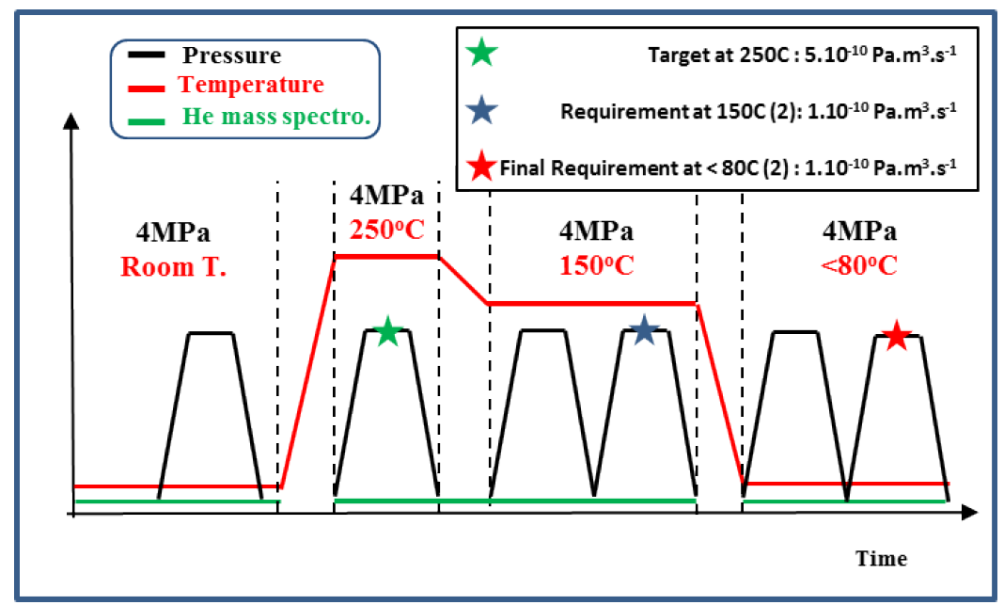
Figure 5-30 Schematic illustration of Hot Helium leak test sequence and related acceptance criteria

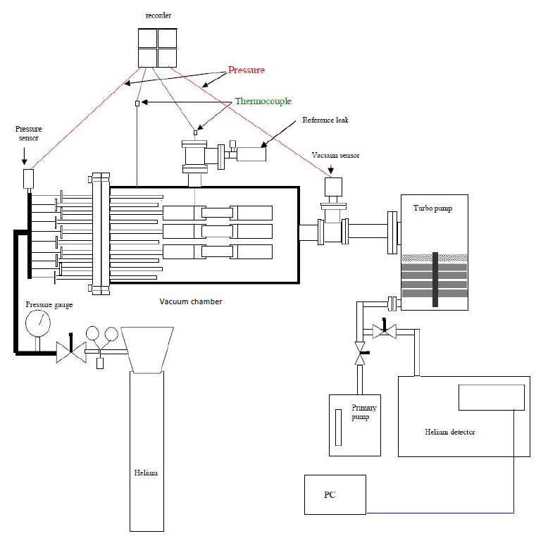
Figure 5-31 Schematic illustration of a hot Helium leak test facility (example)

Geometrical Shape and Tolerances

Introduction
[REQ-176] The geometrical shape and tolerances shall be measured on each final component, including standard parts, after the completion of the manufacturing process.
[REQ-177] The geometrical shape and tolerances shall be measured according to a testing protocol and Dimensional Inspection Plan (DIP) agreed with IO and compliant with the ITER Dimensional Metrology Handbook [AD3].
[REQ-178] The dimensional metrology shall be carried out at room temperature.
The ITER Dimensional Metrology Handbook [AD3] outlines the mandatory requirements for dimensional control of the components, assemblies and systems for the ITER machine. In addition, the handbook provides significant guidance and helpful information on best practice for metrology applications.
The agreement on Testing Protocol and Dimensional Inspection Plan represents a Hold Point, part of the MRR.
[REQ-179] The Contractor shall prepare a dimension report, as a minimum, containing the following information:
- The implemented Dimensional Inspection Plan with all data sheet tables.
- All Meta data files, electronic measurement files e.g. Spatial Analyzer, Polyworks, PCDMS etc. An acceptance or rejection statement on the detected defects.
- Record or Log for Instrument, Personnel and Temperature.
- Drift & Artifact Record for use with Laser Tracker.
- Calibration certificates SHALL BE provided upon request.
- Photograph(s) of each instrument(s) and part in use to provide record of part set up and instrument operations.
Compliance with the requirements on the geometrical shape and tolerances represents a Hold Point.

General Tolerances
[REQ-180] Unless otherwise specified, the dimensions shall satisfy the tolerance Class “m” of ISO 2768-1 [CS4] and tolerance Class “K” of ISO 22081 [CS5] (Replacing ISO 2768-2). General tolerances do not require a specific check unless there are doubts that they have been met.
[REQ-181] The above tolerances also apply to the maximum deviation from the straightness and flatness of straight lines and flat surface, respectively.

Specific Tolerances
[REQ-182] The conformity with the required specific tolerances shall be demonstrated and reported in an appropriate table (DIP). The format of DIP must contain all the necessary information in order that the correct controls can be exercised.
Specific tolerances are shown in the IO 2D General Assembly Drawings, as detailed in the Bill of Materials for the NB Port Liners (16.NL)[AD4].

Component Labelling and Traceability
[REQ-183] The IO and Contractor shall agree to a permanent identification and numbering system, which comply with the IO official numbering system, according to the document ITER Numbering System for Components and Parts (GM3S [AD1]). All components and the main subcomponents shall be clearly marked in a permanent way and in a visible place with the IO official numbering system. All fabrication historical data shall be electronically archived following the IO requirements and templates.
In addition to the coding and marking as defined in the GM3S [AD1] Section 9, before the start of manufacturing activities, the IO and Contractor will agree on a component and sub-component numbering system in line with Blanket numbering system [RD2].

Cleaning
[REQ-184] During assembly and cleaning, particular attention shall be given to the removal of weld spatter, debris and other foreign matter from the coolant passages. Chemical picking and several water rinses shall be performed to remove residuals, flakes and/or powder after the welding procedure.
[REQ-185] Final cleaning shall ensure effective cleaning without damage to the surface finish, coating performance, material properties or metallurgical structure of the materials.
[REQ-186] Final cleaning of the metallic parts of the final components shall be done manually, according to a procedure mutually agreed between the IO and Contractor.
[REQ-187] The Contractor shall submit the proposed cleaning procedure for acceptance in accordance with Section 24 of the ITER Vacuum Handbook [AD2].
The Contractor may consider repeating or carry out a special cleaning process on any item.
[REQ-188] The use of incompatible cleaning materials with vacuum conditions shall be avoided.
[REQ-189] The NBPL shall be properly cleaned and dried before packaging.
The demonstration of meeting the cleaning requirements represents an Authorization-To-Proceed Point.

Packing, preservation & shipping
In addition to the packing, handling, delivery as defined in the GM3S [AD1] Section 10.2 &10.3,
[REQ-190] The handling of the components shall be minimized and strictly controlled to preserve cleanliness.
[REQ-191] The Contractor shall design and supply appropriate packaging, adequate to prevent damage during shipping and handling operations.
[REQ-192] Provision of transportation box handling features (for forklift and slinging) shall be implemented as agreed with IO.
[REQ-193] Components shall be packed with adequate protection from thermal or mechanical stresses which may adversely affect the operation of the component.
[REQ-194] All packing shall be sealed and marked externally stating ITER Vacuum Category that the components inside.
[REQ-195] Handling instructions shall also be clearly marked on the outside of the packaging.
[REQ-196] All parts shall be shipped dry, irrespective of final acceptance testing at the Contractor’s site.
[REQ-197] The use of adhesive tape for the protection and packaging of parts shall be restricted to prevent the risk of contamination from the tape.
[REQ-198] If adhesive tape is used on austenitic stainless steel, the tape shall meet leachable chloride and fluoride limits of 15 ppm and 10 ppm, respectively.
[REQ-199] If it is used, adhesive tape shall be fully removable leaving no residue, using isopropyl alcohol or acetone as solvent to remove all traces of the adhesive.
[REQ-200] To prevent damage and contamination during transit, the packaging of parts shall be done as soon as possible after acceptance testing and final cleaning at the Contractor’s premises. Cleaning and packaging operations may be witnessed by ITER.
[REQ-201] The components shall be entirely enclosed in heat-sealed polyethylene which has been purged and backfilled with dry air (<4000 ppm H₂O).
[REQ-202] Where the purging and backfilling of the polyethylene enclosures is not practical, alternative conditions shall be submitted for IO approval.
[REQ-203] Packaging shall be non-returnable and of a robust nature, suitable for the foreseeable transportation method (for air transport this should include an un-pressurized cargo hold) without damage to the parts.
[REQ-204] One tri-axial accelerometer per each batch of products shipped shall be used.
A 3 -directional ShockLog 298 accelerometer, is preferred

Location for Scope of Work Execution
The Contractor can perform the work at their own location.

IO Documents & IO Free issue items

IO Documents
Under this scope of work, IO will deliver the following documents by the stated date:

Ref | Title | Doc ID | Expected date
1 | Model and drawing of Shied Block 15NDS (Input for fabrication) | ITER_D_XFUSPJ  (New version of NBPL BOM [AD4]) | Dec. 2027  (Before Task-2 Production)
2 | IO recommended coating (if applicable) applied on key for HNB Plate 14 | To be created | Dec. 2027  (After Task-1 Qualification)
3 | Model and drawing for Customization of DNB slot | To be created | Dec. 2027  (After survey of VV Sector 2)
4 | Model and drawing for Customization of DNB standard parts | To be created | Dec. 2027  (After survey of VV Sector 2)
5 | IO recommended coating (if applicable) applied on DNB slot | To be created | Dec. 2028  (After IO Assembly R&D)
6 | Model and drawing (if applicable) for machining back surface (interface with VV) of SB14/16 before integration with HNB plate | To be created | Jun. 2030 (After survey of fully welded VV)
7 | Model and drawing for machining back surface (interface with VV) of Integrated SB15NDx (after SB15NDx HIPed with HNB plate 15) | To be created | Jun. 2030 (After survey of fully welded VV)

Free issue items
Under this scope of work, IO will deliver the following equipment/parts by the stated date:

Ref | Equipment / Part Description | Part Nbr | Expected date
1 | SB15NDx (SB15NDA/NDB/ND, half machining, before HIPing with HNB plate 15) from KODA | 3 | Mid of 2028
2 | SB16NBx (SB16NB and SB16NB1) from KODA | 3 | Mid of 2028
3 | SB14NDx (SB14NDL/NDV/ND) from CNDA | 3 | Mid of 2028
4 | NBPL Standard Parts supplied by IO (Caps and other standard parts if applicable) | TBD | Mid of 2028

IO Service
Under this scope of work, IO will provide the following service by the stated date:

Ref | Equipment / Part Description | Part Nbr | Expected date
1 | NDT (Eddy Current) of welding on hydraulic connections for Integrated SB14 /16 | To be provided | According to manufacturing schedule

Deliverables and Schedule Milestones

Schedule for delivery Hardware
[REQ-205] The Contractor shall deliver the following items/parts, details referring to the NBPL delivery sheet in Bill of Materials for the NB Port Liners (16.NL) [AD4]. The maximum expected duration from the contract signature to the supply of the scope of work is 6 years (72 months).

Ref | Name | Quantity of Supply | Note
1 | DNB liner | 2 | 1 spare
2 | Integrated Shield Block 15NDA | 1
3 | Integrated Shield Block 15NDB | 1
4 | Integrated Shield Block 15ND | 1
5 | Integrated Shield Block 15NDS | 1 | Spare
6 | Integrated Shield Block 14ND | 1
7 | Integrated Shield Block 14NDL | 1
8 | Integrated Shield Block 14NDV | 1
9 | Integrated Shield Block 16NB | 2
10 | Integrated Shield Block 16NB1 | 1
11 | HNB Plate 14NDL | 1 | Spare
12 | HNB Plate 16S | 1 | Spare
13 | M14 Bolt Assembly of DNB liner | 18 | 6 sets as spare
14 | PAD Assembly of DNB liner | 8 | Spare
15 | Standard Parts of HNB Plate 14 | 4 | Spare
16 | Standard Parts of HNB Plate 16 | 8 | Spare
17 | Standard Parts of Integrated SB15NDx | 1 | Spare

List of deliverable documentation
[REQ-206] The Contractor shall provide IO with the documents and data required in the application of this technical specification, the GM3S [AD1] and any other requirement derived from the application of the contract.

You can find here below a minimum list of documentation, but not limited to, that are required within the expected timing:

Doc Category | Document tile | Further Description | Expected Timing  (T0 + x month) *
KOM | Contract Management Plan (or Quality Plan) | GM3S [AD1] Section 8.2 and Ref [16] | T0 + 1
KOM | Subcontractor Acceptance Form (if applicable) | GM3S [AD1] Appendix VI | T0 + 1
KOM | List of Subcontractor | Living document | T0 + 1
KOM | List of Deliverables | Living document [RD10]  GM3S [AD1] | T0 + 1
KOM | Contract Implementation Schedule | Living document  GM3S [AD1] Section 6.1.4.1 | T0 + 1
KOM | Progress Report | GM3S [AD1] Section 6.1.4.2 and Appendix IV/ Appendix II | T0 + 1
KOM | Contract Risk and Opportunities | GM3S [AD1] Section 6.1.4.3 | T0 + 1
KOM | KOM Minutes | GM3S [AD1] Section 6.1.5.1 and Appendix III | T0 + 1
Task 1 | Qualification
Task 1 | Qualification Protocol of mock-up for Integrated SB14 |  | T0 + 8
Task 1 | Qualification Protocol of mock-up for Integrated SB15 |  | T0 + 8
Task 1 | Qualification Protocol of mock-up for Integrated SB16 |  | T0 + 8
Task 1 | Qualification Report of mock-up for Integrated SB14 |  | T0 + 20
Task 1 | Qualification Report of mock-up for Integrated SB15 |  | T0 + 20
Task 1 | Qualification Report of mock-up for Integrated SB16 |  | T0 + 20
Task 2 | Production |  | T0 + 22
MRR Task 2 | Manufacturing and Inspection Plan | GM3S [AD1] Section 8.4.2 and Appendix VIII | T0 + 24
MRR Task 2 | Manufacturing Readiness Review | GM3S [AD1] Section 6.1.5.2.3 | T0 + 24
Task 2 | Welding Data Package |  | Prior to the welding operation
Task 2 | Manufacturing and Test Report for Shield Block 15NDS |  | T0 + 36
Task 2 | Manufacturing and Test Report for HNB Plate 15 |  | T0 + 36
Task 2 | Manufacturing and Test Report for HNB Plate 14 |  | T0 + 48
Task 2 | Manufacturing and Test Report for HNB Plate 16 |  | T0 + 48
Task 2 | Manufacturing and Test Report for NBPL Standard Parts |  | T0 + 48
Task 2 | Manufacturing and Test Report for Integrated SB14 |  | T0 + 68
Task 2 | Manufacturing and Test Report for Integrated SB15 |  | T0 + 68
Task 2 | Manufacturing and Test Report for Integrated SB16 |  | T0 + 68
Task 2 | Manufacturing and Test Report for DNB liner |  | T0 + 68
FAT | FAT readiness review | GM3S [AD1] Section 6.1.5.2.4 | T0 + 68
DRR | Release Note | GM3S [AD1] Appendix VII | T0 + 70
DRR | Package and Packing List | GM3S [AD1] Appendix XII | T0 + 70
DRR | Delivery Report | GM3S [AD1] Appendix XIII | T0 + 70
DRR | Storage & Preservation requirement | GM3S [AD1] Appendix XIV | T0 + 70
DRR | Delivery Readiness Review | GM3S [AD1] Section 6.1.5.2.5 and Ref [5] | T0 + 70
Close-out |  |  | T0 + 72
(*) T0= Contract signature date; X in months.

[REQ-207] Contractor shall prepare their document schedule based on the above and using the template available in the GM3S [AD1] appendix II (click here to download).

Quality Assurance requirements
The Quality class under this contract is Quality Class 1, the GM3S [AD1] Section 8 applies in line with the defined Quality Class.

Safety requirements
No specific safety requirement related to Protection Important Components and Protection Important Activities apply.

Nuclear class Safety
No specific safety requirement related to Pressure Equipment and Nuclear Pressure Equipment apply.

Seismic class
The Seismic class under this contract is Seismic Class 2.

Special Management requirements
Requirement for the GM3S [AD1] Section 6 applies in full.

CAD design requirements
This contract requires for CAD activities, the GM3S [AD1] Section 6.2.2.2 applies.

Appendix

Appendix A1 - Qualification of Hot Isostatic Pressing for CuCrZr to Steel and Steel to Steel bonds

SCOPE
The technical specification for supply of NBPL requires a HIP qualification. This Appendix A1 specifies how to qualify these joints and what is the range of approval for each essential parameter.
[A1_REQ-1] The test for qualification of HIP joint shall be carried out after the joint has been subjected to the same manufacturing thermal cycles as those of the NBPL, and the material properties shall be in accordance with the acceptance criteria stated hereinafter.

Preliminary HIP Procedure Specification
[A1_REQ-2] The preliminary HIP Procedure Specification shall be prepared by the Contractor and submitted it to the IO for approval.
[A1_REQ-3] This document shall compile all the essential variables required in this specification and the samples cutting and testing scheme.
[A1_REQ-4] A procedure/protocol to perform the qualification shall be produced.

Qualification of the HIP procedure
HIP Procedure Specification
Acceptance by IO
Qualification and record
Preliminary HIP Procedure Specification
Witnessing by IO representative
Acceptance by IO
Figure A1_ 1 HIP procedure qualification workflow

Geometry of the test piece
[A1_REQ-5] Geometry of test pieces shall permit to carry out all the tests required in Appendix A1.

Essential parameters

Parent Materials
[A1_REQ-6] The CuCrZr shall be provided in the proposed condition identified in the protocol for HIP Joint.
[A1_REQ-7] The qualification is available only for the tested materials and combination of materials (according to the standard or the material general naming reported in the material certificate).
[A1_REQ-8] Any type of joints in the products, e.g., CuCrZr/SS and SS/SS, shall be qualified separately or integrated (with agreement by IO).
[A1_REQ-9] If powder is used, it shall be qualified.
[A1_REQ-10] The HIPed powder thickness shall be the maximum allowable in production.
[A1_REQ-11] The powder material specification shall be accepted by IO.

Surface Roughness
[A1_REQ-12] The surface roughness of the machined test pieces to be assembled for HIPing qualification tests shall be the maximum allowable in production.

Cleanliness before and during operation
[A1_REQ-13] A Cleaning procedure shall be approved by IO.
[A1_REQ-14] The Contractor shall define essential parameters measurable in accordance with its cleaning procedure.

Gaps and misalignments due to machining and assembly tolerances
[A1_REQ-15] The test piece shall be representative of the component intended for the fabrication process and shall bear the maximum tolerances acceptable in production during the assembly in preparation for HIPing, in terms of gaps and/or misalignments resulting from the machining and assembly tolerances.

Welds
[A1_REQ-16] If tack welds, seal welds, or structural welds are included in the final HIPed joint, they shall also be included in the test piece.

Canister
[A1_REQ-17] The HIP Canister:
- Shall be made of the same material (in terms of standard designation) as in production
- Have a written procedure for the sealing of the evacuation pipe.
[A1_REQ-18] If one of these parameters change, a new qualification shall be performed.

HIP furnace
[A1_REQ-19] The HIP furnace shall be demonstrated to be able to follow the HIP process parameters with a product of the same weight and size as the final product.
[A1_REQ-20] The HIP furnace qualification shall be limited to:
- Ramp up rate for temperature, pressure, and their relationship
- Hold step (Temperature, pressure, duration/time)
- Ramp down rate for temperature, pressure, and their relationship
- Furnace conditioning (outgassing), working gas and its purity
[A1_REQ-21] The Contractor shall give tolerances for each parameter. These tolerances will be the limit accepted during production.
[A1_REQ-22] The test piece shall undergo the same heat treatment and HIP sequence as in production.

HIP cycles
[A1_REQ-23] The HIP cycles in the products shall be the same as in the qualification, i.e., single HIP does not qualify two step HIPs, nor reverse.

Heat treatment
Heat treatment is needed to recover the mechanical properties of stainless steel and copper alloy.
[A1_REQ-24] The heat treatment history in product shall be the same as in the qualification.

Contamination protection
For two steps HIP, the internal cooling channels may be already made and will contact the working gas during HIP and/or heat treatment. In the heat treatment, these channels need to be protected (by inertia gas).
[A1_REQ-25] Any material (SS and CuCrZr) exposed to the working gas shall be demonstrated in the qualification for the same exposure in the HIP process and same protection in heat treatment.
[A1_REQ-26] If any method is needed in the production to remove oxidation layer, it shall be demonstrated in the qualification.

Tests
[A1_REQ-27] Samples shall be taken in an area free of discontinuities found by NDT.
The number of test samples specified in below chapters are for each type of the joint (SS/SS, SS/Cu) unless the type is not applicable.

Destructive test
- Transverse Tensile test
[A1_REQ-28] The Transverse Tensile test shall be done in accordance with EN ISO 4136 [CS12].
[A1_REQ-29] 3 samples for the test at room temperature and 3 for the test at 250°C shall be taken.
[A1_REQ-30] The following parameters shall be measured:
- Rm (MPa)
- Rp0.2 (MPa)
[A1_REQ-31] The tensile strength of the joint shall be compliant with the material specification relevant for the base metal (the weakest material in case of dissimilar joints).
- In case a joint of dissimilar materials, the rupture should not occur at the joint.
- In case of a joint of similar materials, the yield strength shall be compliant with the material specification relevant for the base metal.
[A1_REQ-32] For the material of CuCrZr, the minimum tensile and yield strength shall meet the requirements specified in Appendix A of SDC-IC [CS1] for CuCrZr Treatment C and summarised in Table 5-2 in Section 5.11.2.1.
- Bend test
[A1_REQ-33] Test specimens and test method for bend testing shall be in accordance with EN ISO 5173 [CS13].
Scaled-down specimens can be used.
[A1_REQ-34] A longitudinal () bend test specimens shall be used.
[A1_REQ-35] The test specimens should be bent through 180° unless the strength and/or ductility of the parent metal impose other limitations.
[A1_REQ-36] During testing, the test specimens shall not reveal any imperfection of a length > 3 mm in any direction.
[A1_REQ-37] Imperfections not initiated by a HIPed joint defect, appearing at the corners of a test specimen during testing, shall be ignored in the evaluation.
- Metallographic examination
[A1_REQ-38] 3 samples shall be taken from each type of bonded joint (CuCrZr/SS and SS/SS), targeting both edge and centre areas of the joints.
[A1_REQ-39] Macroscopic examination shall be carried out in accordance with ISO 17639 [CS14]. The Acceptance criteria shall be in accordance with EN ISO 5817 [CS15].
[A1_REQ-40] The evaluation of the microscopic structure shall be done according to EN ISO 17639 [CS14]:
- No discontinuity or foreign inclusion are allowed in the HIP bond detected by microscopic examination (magnitude x50)
- No alteration of the microstructure of the base metal, on both sides of the HIP bond.
- Oxidation
[A1_REQ-41] Any type of material (CuCrZr and SS) in the product which exposes to HIP working gas, shall be simulated in the qualification and visual examined the surface oxidation status after the whole HIP cycles and heat treatment.
[A1_REQ-42] Oxidation shall be minimized. To evaluate oxidation of HIP joints and adjacent areas on austenitic Cr-Ni steels, the following acceptance criteria based on DIN 25410:2012 [CS16] is recommended to be proposed in VT and endoscopic examination procedure issued by the Contractor and accepted by the IO.
The temper colours and shades range as follows: yellow, brown, violet, dark blue, medium blue, light blue, light gray, and gray. In general, test colours from classes 1 to 3 are permitted. The following criterion, as shown in Figure A1_ 2, is recommended to be considered when accepting and rejecting oxidized welds and adjacent areas on austenitic Cr-Ni stainless steels.
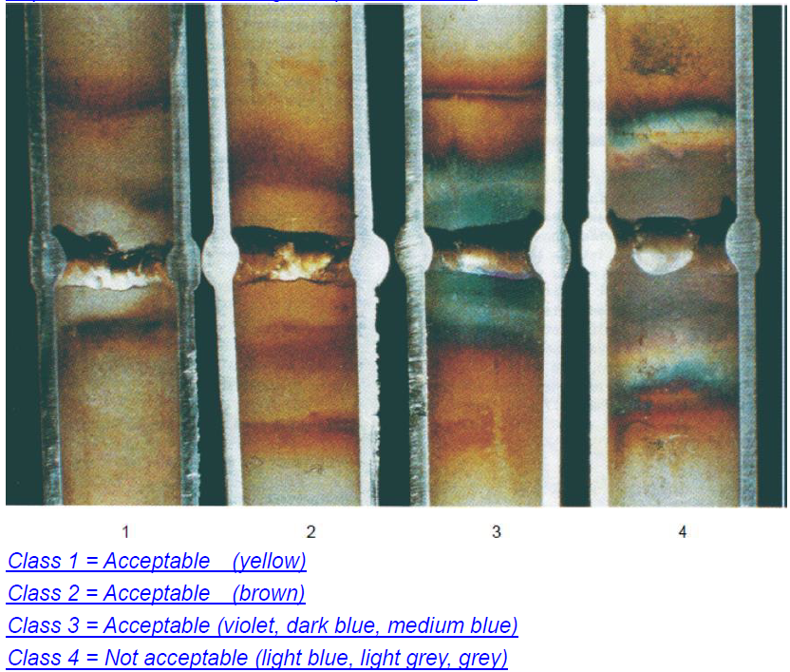
Figure A1_ 2 Class definition of oxidized welds and adjacent areas on austenitic Cr-Ni stainless steels
[A1_REQ-43] The Contractor shall develop proper processes in working piece cleaning, furnace conditioning, working gas purity, protection in heat treatment process, and etc., to achieve the surface oxidation as low as possible.
[A1_REQ-44] The Contractor shall develop a chemical cleaning procedure for IO acceptance, which may be used in the qualification and in the product in case of the oxidation exceeds the above limit. The procedure shall define a critical level of oxidation. Above this level, the product has to be rejected and below this level, the oxidation layer can be removed using the procedure

NDT
- Penetrant test
[A1_REQ-45] Penetrant test shall be done in accordance with EN ISO 3452-1 [CS17]. Acceptance criteria shall be in accordance with ISO 23277 [CS18] level 2X.
- UT
[A1_REQ-46] The UT inspection shall be done as much as possible with a beam perpendicular to the joint surface (longitudinal waves).
[A1_REQ-47] UT shall be done with the same procedure and acceptance criteria used for production.
- Micro hardness test
[A1_REQ-48] Vickers hardness measurement shall be performed in accordance with EN ISO 9015-2 [CS19]. It shall be at least 2 measurement lines per sample, and typically 10 measurement points/5 mm in a measurement line crossing bimetallic joint interface.
[A1_REQ-49] Maximum acceptable value is 300 HV across the thickness, and minimum value is as for the supplied solution annealed materials.

- Leak and burst test
[A1_REQ-50] A protocol for the pressure and burst tests (including sample geometry) shall be provided by the Contractor for IO agreement.
This test is to qualify the HIP parameters with joint types and deemed not relevant to HIP furnace.
[A1_REQ-51] Three mock-ups with dimensions representative of the vacuum boundary (design to be agreed with IO) for each type of joints (CuCrZr/SS and SS/SS, if it appears in the product as vacuum/pressure boundary) shall be manufactured and subject to the following tests:
1. Dimensional test (length, width, height and CuCrZr cover flatness).
2. He leak test at Room Temperature (RT).
3. Hot pressure - He leak test
a. Pressurisation at 2±0.3 MPa by means of He gas at RT.
b. Heating the component at 150 ±10 ºC.
c. Pressurisation at 6±0.3 MPa by means of He gas at 150±10 ºC. Pressure shall be increased in 1 min and kept at 6±0.3 MPa for 15 min.
d. The vacuum level in the vacuum chamber: ≤ 1×10⁻² Pa (1×10⁻⁴ mbar)
4. Repeated pressure test at RT from 0±0.5 MPa up to 8±0.5 MPa for 20 cycles.
5. Perform again hot pressure - He leak test (same as point 3 above).
6. Perform again dimensional test (same as point 1 above).
7. Burst test (hydrostatic/pneumatic)
a. Pressurisation at 20±2 MPa by means of liquid at RT. Pressure shall be kept at 20±2 MPa for 30 min, if the mock-ups shall not burst at a pressure lower than 20 MPa.
8. Leak test at room temperature

The Contractor shall check the performance of the mock-up under the above test conditions against the SDC-IC [CS1] criteria. If any violent, it should be reported to IO for decision on “change design or adjust the test conditions”.
[A1_REQ-52] As regards the He leak test at RT and the hot pressure He leak test, the sensitivity of the He detector shall be better than 4×10⁻¹¹ Pa.m³/s (4×10⁻¹⁰ mbar l/s).
[A1_REQ-53] The max leak rate for all mock-ups shall be < 1×10⁻¹⁰ Pa.m³/s (1×10⁻⁹ mbar l/s) before and after the repeated pressure test.
Alternative methods can be proposed by Contractor and subject to IO’s acceptance.

HIP Process Qualification Record
[A1_REQ-54] If one test failed, the qualification shall not be considered acceptable.
[A1_REQ-55] The HIP Process Qualification Record (HPQR) shall compile all results including tests results.
[A1_REQ-56] The HPQR shall be accepted by IO.

- End of the Document -

